A Project-B Report
On
Towards Trustworthy AI Meteorology: A
Context-Aware LLM Framework for Multi-Scale Weather Reasoning and Verification
Submitted in partial fulfillment of the requirement of
University of Mumbai for the Degree of
Bachelor of Technology
In
Computer Engineering
Submitted By
Parth Milind Ghadge
Krish Vinod
Abinraj Lalraj Punnakkaparambil
Adithya Saji Kumar
Supervisor
Dr. Dhiraj Amin

Department of Computer Engineering
PILLAI COLLEGE OF ENGINEERING (AUTONOMOUS)
New Panvel – 410 206
UNIVERSITY OF MUMBAI
Academic Year 2026-27

Department of Computer Engineering
Pillai College of Engineering
New Panvel – 410 206

CERTIFICATE
This is to certify that the requirements for the Major Project-B entitled ‘Towards Trustworthy AI Meteorology: A Context-Aware LLM Framework for Multi-Scale Weather Reasoning and Verification’ have been successfully completed by the following students:
Name Roll No.
Parth Milind Ghadge B717
Krish Vinod B724
Abinraj Lalraj Punnakkaparambil B749
Adithya Saji Kumar B725

In partial fulfillment of Bachelor of Technology of Mumbai University in the Department of Computer Engineering, Pillai College of Engineering, New Panvel – 410 206 during the Academic Year 2026 - 2027

_____________________
Supervisor
(Dr. Dhiraj Amin)

____________________ _____________________
Head, Department of Computer Engineering Principal
(Dr. Sharvari Govilkar) (Dr. Sandeep M. Joshi)
Department of Computer Engineering
Pillai College of Engineering
New Panvel – 410 206

PROJECT APPROVAL FOR B.Tech
This Major Project-B entitled “Towards Trustworthy AI Meteorology: A Context-Aware LLM Framework for Multi-Scale Weather Reasoning and Verification” by Parth Milind Ghadge, Krish Vinod, Abinraj Lalraj Punnakkaparambil and Adithya Saji Kumar are approved for the degree of B.Tech. in Computer Engineering.

Examiners:
1. ______________________
2. ______________________
Supervisors:
1. ______________________
2. ______________________
Chairman:
1. ______________________

Date:
Place:

Department of computer engineering
Pillai College of Engineering
New Panvel – 410 206

DECLARATION
We declare that this written submission for B.Tech entitled “Towards Trustworthy AI Meteorology: A Context-Aware LLM Framework for Multi-Scale Weather Reasoning and Verification” represents our ideas in our own words and where others' ideas or words have been included. We have adequately cited and referenced the original sources. We also declared that we have adhered to all principles of academic honesty and integrity and have not misrepresented or fabricated or falsified any ideas / data / fact / source in our submission. We understand that any violation of the above will cause disciplinary action by the institute and also evoke penal action from the sources which have thus not been properly cited or from whom paper permission has not been taken when needed.

Project Group Members:
Parth Milind Ghadge: ______________
Krish Vinod: ______________
Abinraj Lalraj Punnakkaparambil: ______________
Adithya Saji Kumar: ______________
Date:
Place
Table of Contents
Abstract ........................................................................................................................................ i
List of Figures ............................................................................................................................. ii
List of Tables .............................................................................................................................. iii
1. Introduction ............................................................................................................................. 1
1.1 Fundamentals .................................................................................................................... 1
1.2 Objectives ......................................................................................................................... 2
1.3 Scope ................................................................................................................................. 3
1.4 Organization of the Project Report ................................................................................... 4
2. Literature Survey .................................................................................................................... 5
2.1 Introduction ....................................................................................................................... 5
2.2 Literature Review ............................................................................................................. 6
2.3 Summary/Inference of Literature Survey ......................................................................... 14
2.4 Research Gap .................................................................................................................... 17
3. Implemented System ............................................................................................................. 20
3.1 Overview ........................................................................................................................... 20
3.1.1 Existing System Architecture ................................................................................... 22
3.1.2 Proposed System Architecture ................................................................................. 25
3.2 Implementation Details ..................................................................................................... 28
3.2.1 Algorithms / Techniques .......................................................................................... 28
3.2.2 Sequence Diagram ................................................................................................... 29
3.2.3 Hardware and Software Specifications .................................................................... 31
4. Result and Discussion ............................................................................................................. 33
4.1 Sample of Inputs, Dataset Used, and Outputs .................................................................. 33
4.1.1 Input Data and Experiment Design .......................................................................... 33
4.1.2 Pipeline Outputs ....................................................................................................... 33
4.1.3 Dataset Summary ..................................................................................................... 34
4.2 Evaluation Parameters ...................................................................................................... 34
4.2.1 Component-Level Scores ......................................................................................... 34
4.2.2 Composite Confidence Score ................................................................................... 35
4.2.3 Derived Metrics ....................................................................................................... 35
4.3 Performance Evaluation .................................................................................................... 36
4.3.1 Overall System Performance ................................................................................... 36
4.3.2 Component-Level Analysis ...................................................................................... 36
4.3.3 Performance Across Climate Zones and Configuration Variants ............................ 37
4.3.4 Claims and Hallucination Analysis .......................................................................... 38
4.3.5 Pipeline Latency ...................................................................................................... 38
4.3.6 Discussion ................................................................................................................ 38
5. Impacts ................................................................................................................................... 40
5.1 Impact on the Real World ............................................................................................... 40
5.2 Societal Impact ............................................................................................................... 40
5.3 Technological Impact ...................................................................................................... 41
5.4 Environmental and Climate Impact ................................................................................ 41
5.5 Economic Impact .............................................................................................................. 42
5.6 Academic and Research Impact ........................................................................................ 42
6. Summary .................................................................................................................................. 44
References .................................................................................................................................... 45
Survey Paper ............................................................................................................................... 46
Acknowledgement ....................................................................................................................... 59

Abstract
Towards Trustworthy AI Meteorology is an LLM-agent framework designed for the generation of explainable, multi-scale weather reports through structured hierarchical forecast reasoning. In contrast to conventional approaches that model forecasts as flat time series, the proposed system performs multi-scale reasoning across hourly, 6-hourly, and daily temporal aggregations, effectively capturing both short-term dynamics and long-term synoptic trends. A core reasoning agent transforms structured meteorological inputs into coherent natural-language narratives while simultaneously extracting a compact set of keywords that summarize dominant meteorological events. These keywords function as semantic anchors for validating temporal coherence and factual consistency within the generated reports. To further ensure causal correctness across temporal scales, the framework incorporates a temporal event graph that explicitly models meteorological relationships-such as pressure tendencies leading to wind shifts and temperature fluctuations providing an additional layer of graph-based consistency checking. Extensive experiments utilizing OpenMeteostat, OpenWeather and Meteostat data demonstrate that the integration of hierarchical context and keyword-based validation significantly enhances the interpretability and robustness of LLM-generated weather narratives. The proposed framework offers a reproducible approach for the semantic evaluation of automated meteorological reporting and advances agent-based reasoning for the generation of specialized scientific text.
List of Figures
Fig 3.1 Existing System Architecture 22
Fig 3.2 Proposed (Implemented) System Architecture 25
Fig 3.3 Sequence Diagram 30
List of Tables
Table 2.1 Summary of Literature Survey 14
Table 3.1 Data Sources and Experimental Evaluation Set 31
Table 3.2 Verification Engine Specification 31
Table 3.3 Hardware and Software Specifications 32
Table 4.1 Aggregate Verification Scores Across 207 Pipeline Runs 36
Table 4.2 Overall Confidence Score by Climate Zone 37

Chapter 1
Introduction

1.1 Fundamentals
The Towards Trustworthy AI Meteorology system is based on the principle of multi-scale temporal reasoning, which moves beyond traditional flat time-series forecasting approaches. Instead of analyzing weather data at a single time resolution, the proposed system interprets atmospheric information across multiple temporal levels. Specifically, the framework processes forecast data at three different time scales: hourly, 6-hourly, and daily. The hourly level captures short-term local atmospheric changes such as rapid temperature variations or wind shifts. The 6-hourly aggregation helps identify mesoscale patterns and reduces short-term noise in the data, while the daily level highlights broader synoptic trends and overall weather transitions.
To construct these temporal summaries, the system aggregates meteorological parameters using appropriate statistical operations. For example, temperature and humidity values are summarized using means, minima, and maxima; precipitation is aggregated using cumulative sums; and wind direction is computed using circular averaging techniques. These aggregated representations allow the system to distinguish meaningful weather patterns from random fluctuations that could otherwise mislead prediction or interpretation models.
A central component of the framework is the semantic validation layer, which generates a compact set of weather keywords representing dominant atmospheric events. Typically, three to five keywords are extracted to summarize key conditions across the forecast period, such as rainfall, pressure drop, wind shift, or cooling trends. These keywords serve as semantic anchors, ensuring that the final natural-language weather report remains consistent with the underlying meteorological data.
To maintain transparency and interpretability, the system also produces a structured proof-block that connects the generated keywords with numerical signals derived from the weather dataset. This block explicitly lists relevant indicators such as pressure changes, temperature ranges, wind variations, and precipitation levels. By linking each descriptive keyword with measurable weather parameters, the system provides a clear reasoning trail that explains how specific weather events are inferred from the input data.
The system architecture follows a modular design composed of three specialized agents: the Assistant, the Meteorologist, and the Writer. The Assistant is responsible for collecting and normalizing weather data from open sources such as OpenMeteostat, OpenWeather and Meteostat, and organizing it into structured input formats. The Meteorologist agent performs the main analytical reasoning by examining the hierarchical weather aggregates and identifying dominant atmospheric patterns. Finally, the Writer agent converts the technical analysis into readable weather narratives tailored for specific audiences such as power system engineers, disaster management authorities, or general users.
Importantly, the framework relies on in-context reasoning using structured prompts and serialized numerical data rather than model fine-tuning. This design makes the system reproducible, interpretable, and easier to adapt to different weather datasets while maintaining transparency in its reasoning process.

1.2 Objectives
The primary objective of this project is to develop an LLM-based hierarchical weather interpretation framework capable of transforming structured meteorological data into clear and explainable natural-language weather reports. Traditional forecasting systems often present predictions as numerical tables or flat time-series outputs, which can be difficult for non-experts to interpret and may not clearly explain the relationships between atmospheric variables. This project aims to address that limitation by introducing a hierarchical reasoning approach that analyses weather data across multiple temporal scales and generates coherent narratives that reflect the underlying meteorological processes.
To achieve this, the project seeks to develop a hierarchical reasoning scheme for interpreting tabular weather forecasts across multiple temporal resolutions - hourly, six-hourly, and daily - so that both short-term local variations and longer-term atmospheric trends can be captured effectively. Building upon this, the system is designed to generate a causally consistent cross-scale weather narrative that explains meteorological events while maintaining coherence between observations derived from different temporal aggregations.
A further objective is to implement a semantic validation mechanism using weather keywords, wherein a compact set of dominant atmospheric descriptors summarises the primary weather conditions and their progression throughout the forecast period. Complementing this, a verifiable connection between textual descriptions and numerical weather data is established through a structured proof-block that highlights relevant signals such as pressure changes, wind shifts, temperature ranges, and precipitation levels.
The project additionally aims to incorporate a temporal event graph that represents causal relationships between meteorological variables, enabling the system to verify that generated weather explanations are logically consistent with observed atmospheric patterns. Finally, the project seeks to create a reproducible processing pipeline that integrates structured meteorological data from publicly available sources such as OpenMeteostat, OpenWeather and Meteostat, allowing the automated generation and validation of weather narratives based on real forecast data.

1.3 Scope
The scope of this project includes the design, implementation, and evaluation of the Towards Trustworthy AI Meteorology, an LLM-agent framework developed to bridge the gap between structured meteorological data and interpretable natural-language weather reports. The system focuses on transforming numerical forecast tables into coherent explanations that describe atmospheric conditions and their evolution over time. The operational range of the framework is limited to a medium-range forecast horizon of approximately 5 to 6 days (120 hours), enabling the analysis of both short-term local weather variations and broader atmospheric trends.
The framework operates using publicly available meteorological datasets and is designed to function across diverse geographical regions. Weather data is collected from open sources, specifically OpenWeather and OpenMeteostat for real-time forecast information and Meteostat for historical climatological context. The system follows a modular architecture composed of three main agents: the Assistant, responsible for collecting and organising meteorological inputs; the Meteorologist, which performs analytical reasoning over the structured weather data; and the Writer, which converts the analytical output into clear and structured weather narratives.
With respect to technical and functional boundaries, the system processes several atmospheric variables including near-surface air temperature, feels-like temperature, dew point, relative humidity, wind speed and direction, wind gusts, precipitation, and horizontal visibility. Temporal interpretation is supported through a three-level hierarchy consisting of hourly data for capturing short-term dynamics, six-hourly aggregation for identifying mesoscale patterns and reducing noise, and daily summaries for characterising broader weather trends. Forecast data obtained from OpenWeather and OpenMeteostat is complemented with climatological information from Meteostat to support meaningful contextual interpretation of weather patterns.
In terms of output, the system generates a structured interpretation comprising a natural-language weather summary, a compact proof-block describing the numerical signals underlying the interpretation, and a set of weather keywords that summarise the dominant atmospheric events. Rather than relying on model fine-tuning, the project demonstrates that interpretable weather narratives can be produced through structured prompts and serialised meteorological data using in-context reasoning alone. Finally, the Writer component adapts the generated weather explanations for different user contexts, including domains such as risk analysis, energy planning, and extreme weather monitoring, while preserving the factual integrity of the analytical output.

1.4 Organization of the Project Report
This report is divided into six chapters. Chapter 1 introduces the project and explains the fundamental concepts underlying the Towards Trustworthy AI Meteorology system, including multi-scale temporal reasoning, hierarchical weather aggregation, and LLM-based natural language generation. It also presents the motivation behind the project, along with its defined objectives and scope. Chapter 2 presents a detailed literature survey covering existing research related to automated weather reporting, time-series interpretation, and the application of Large Language Models for meteorological data analysis, while examining the advantages and limitations of each reviewed work. Chapter 3 outlines the proposed system methodology, describing the overall architecture and the key stages involved, including data acquisition, hierarchical temporal aggregation, LLM-based forecast generation, weather event detection, verification and consistency checking, and causal reasoning using a weather event graph. Chapter 4 presents the results and discussion, covering the experimental design, the evaluation parameters, and the performance of the framework across multiple climate zones. Chapter 5 discusses the real-world, societal, technological, environmental, economic, and academic impacts of the framework. Finally, Chapter 6 concludes the report by summarising the work carried out, highlighting the key contributions of the proposed framework, and suggesting future improvements for enhancing the system's capabilities in automated meteorological reporting.

Chapter 2
Literature Survey

2.1 Introduction
Meteorological forecasting has evolved significantly over time, progressing from early approaches based on human observation and empirical knowledge to advanced computational techniques. Traditional forecasting methods were largely dependent on Numerical Weather Prediction (NWP) models, which simulate atmospheric processes using mathematical equations. Although these models provide accurate forecasts, they are computationally intensive and typically produce results in the form of large numerical datasets that are difficult for non-experts to interpret.
Recent advancements in Artificial Intelligence (AI) and Deep Learning (DL) have introduced new methods for analyzing large volumes of meteorological data and improving forecasting accuracy. These models are capable of processing complex atmospheric patterns and generating predictions based on historical and real-time weather data. However, the outputs of such systems are usually presented as numerical tables or graphical representations, which still require expert interpretation.
As a result, an interpretability gap exists between raw meteorological data and the human-readable explanations required by decision-makers in fields such as agriculture, disaster management, energy planning, and transportation. Addressing this challenge has motivated research into systems that can convert structured weather data into clear and informative natural-language descriptions.
This literature survey reviews existing research related to automated weather reporting, time-series interpretation using AI models, and the application of Large Language Models (LLMs) for data-to-text generation. The objective is to examine how previous studies have addressed the challenges of interpreting meteorological data and to identify approaches that support explainable and structured weather narrative generation, which forms the foundation of the proposed Towards Trustworthy AI Meteorology framework

2.2 Literature Review
Omni-Weather: A Unified Multimodal Model for Weather Radar Understanding and Generation [1]
Authors: Zhou et al.
Year: 2026
Summary:
Omni-Weather proposes a unified multimodal framework that combines weather radar prediction with reasoning-based explanation generation, integrating weather radar images with textual explanations to provide both predictive and diagnostic insights into atmospheric phenomena. Using multimodal deep learning, radar data analysis, and chain-of-thought reasoning datasets, the study finds that integrating radar understanding with explanation generation improves the interpretability of weather prediction systems. However, the model requires large radar datasets and computationally intensive training. Overall, the work demonstrates the potential of multimodal AI systems for both prediction and interpretation in meteorology.
Weather-R1: Logically Consistent Reinforcement Fine-Tuning for Multimodal Reasoning in Meteorology [2]
Authors: Wu et al.
Year: 2026
Summary:
Weather-R1 focuses on improving logical reasoning consistency in weather forecasting models, identifying a problem called self-contradictory reasoning, where the explanation a model generates may contradict its final prediction. To address this, the authors introduce Logically Consistent Reinforcement Fine-Tuning (LoCo-RFT), which rewards logically coherent reasoning paths during training. Using reinforcement fine-tuning, logical consistency training, and multimodal meteorological reasoning, the study finds that the proposed strategy improves logical alignment between reasoning steps and final predictions. However, the training process requires additional computational resources and carefully designed reward functions. Overall, the work provides a reinforcement learning approach to improve logical consistency in meteorological AI systems.
Multi-Scale Weather Forecasting Using Deep Learning Architectures with Chennai Climate Data [3]
Authors: Pavithran et al.
Year: 2025
Summary:
This research examines ways to enhance multi-scale weather forecasts by comparing LSTM, LSTM-CNN, and LSTM-Transformer architectures for predicting temperature, humidity, and rainfall, highlighting the "urgent requirement" for frameworks that can produce forecasts across various temporal resolutions within a single unified model, with a specific focus on urban hubs like Chennai, where high climatic variability demands real-time decision support. Using LSTM networks, CNN models, sequence-to-sequence modeling, walk-forward cross-validation, Keras Tuner hyperparameter optimization, Min-Max scaling, and Transformer architectures for time-series forecasting, the study finds that LSTM-CNN performed best for short-term forecasts by extracting local patterns, while LSTM-Transformer was superior for long-range forecasting using global attention mechanisms, with rainfall remaining the most challenging parameter due to its stochastic nature. However, the dataset is geographically limited to the Chennai region, and the purely data-driven models do not explicitly incorporate atmospheric physics, which may limit generalizability for rare events. Overall, the work provides empirical evidence supporting the importance of multi-scale modeling in weather prediction systems and the creation of region-specific, multi-scale climate prediction systems for agricultural scheduling and disaster preparedness.
Hierarchical AI-Meteorologist: LLM-Agent System for Multi-Scale and Explainable Weather Forecast Reporting [4]
Authors: Sukhorukov et al.
Year: 2025
Summary:
This paper introduces the Hierarchical AI-Meteorologist framework, an agent-based system designed to generate explainable weather forecast narratives from structured meteorological data, processing weather information across three temporal scales (hourly, six-hourly, and daily). Instead of treating weather data as a flat time series, the framework performs hierarchical reasoning to identify atmospheric trends and generate coherent natural-language weather reports, with a key innovation being the use of weather keywords combined with a structured proof-block that links textual explanations with numerical meteorological signals. Using hierarchical temporal aggregation, an LLM-agent architecture, keyword extraction, proof-block validation, and structured prompting, the study finds that the hierarchical reasoning approach improves the coherence and interpretability of generated weather narratives, while the keyword-proof coupling ensures that generated explanations remain aligned with the underlying meteorological data. However, the system relies on structured meteorological inputs and does not directly handle raw meteorological simulation outputs, and it also depends on the quality of prompt design and the consistency of LLM reasoning. Overall, the work provides a novel framework for explainable weather reporting using hierarchical reasoning and structured validation mechanisms.
Real-Time Data Integration and Weather Reporting Automation for Extreme Weather Risk Analytics in Indonesia [5]
Authors: Arifani et al.
Year: 2025
Summary:
This study develops a cloud computing-based system that integrates national weather data in real time and automates the generation of forecast reports through an interactive spatial dashboard, addressing the inefficiencies and human errors associated with manual reporting during extreme events in Indonesia and using asynchronous processing to handle simultaneous multi-province information needs. Using Google Cloud Platform (GCP), a Flask backend, REST API integration (OpenWeatherMap), and Leaflet.js heatmap visualization, the study finds that the system provides integrated weather data with latency under one second and can generate automated reports for all provinces in minutes, with user satisfaction exceeding 90% for risk visualization and ease of use. However, the effectiveness of the framework depends heavily on the quality of external contextual data provided to the model, and API request limits necessitated the implementation of a backend caching strategy. Overall, the work demonstrates a scalable infrastructure for national-scale weather risk analytics to support maritime and disaster management sectors.
Time Series Forecasting as Reasoning: A Slow-Thinking Approach [6]
Authors: Yucong Luo, Yitong Zhou, Mingyue Cheng, et al.
Year: 2025
Summary:
This paper introduces the Time-R1 framework, which applies a reasoning-based approach to time series forecasting using Large Language Models. Traditional forecasting models typically follow a fast-thinking paradigm, generating predictions directly from historical patterns without explicit reasoning steps, whereas Time-R1 trains LLMs to perform deliberate step-by-step reasoning before producing forecasts, generating intermediate reasoning processes that help interpret temporal dependencies and improve the reliability of predictions across different time series datasets. Using a two-stage reinforcement fine-tuning framework consisting of Supervised Fine-Tuning (SFT) followed by Reinforcement Learning with Group-based Relative Importance for Policy Optimization (GRIP), the study finds that the slow-thinking reasoning strategy significantly improves forecasting performance by enabling the model to detect regime changes, understand temporal dependencies, and generate interpretable reasoning paths before producing predictions. However, the framework requires higher computational resources due to the reinforcement learning phase and the generation of multiple reasoning trajectories during training. Overall, the work introduces a new forecasting paradigm in which Large Language Models perform structured reasoning before generating predictions, improving both prediction accuracy and interpretability.
LLM-PS: Empowering Large Language Models for Time Series Forecasting with Temporal Patterns and Semantics [7]
Authors: Jialiang Tang, Shuo Chen, Chen Gong, Jing Zhang, Dacheng Tao
Year: 2025
Summary:
This paper proposes LLM-PS, a framework designed to improve time series forecasting using Large Language Models by incorporating temporal patterns and semantic information from time series data. Traditional LLM-based forecasting approaches often struggle because time series data contain sparse semantics and complex temporal patterns that differ from the textual data used during LLM pretraining, so the proposed framework integrates pattern extraction and semantic learning modules that allow the model to capture both short-term fluctuations and long-term trends, and combines these representations with an LLM backbone to enable better understanding of temporal dependencies and more accurate forecasts. Using a Multi-Scale Convolutional Neural Network (MSCNN) for extracting multi-scale temporal patterns, a Time-to-Text (T2T) semantic extraction module, wavelet-based temporal pattern decomposition, and parameter-efficient fine-tuning with Low-Rank Adaptation (LoRA), the study finds that LLM-PS achieves state-of-the-art performance across multiple time series forecasting benchmarks, outperforming existing LLM-based and deep learning models in long-term, short-term, few-shot, and zero-shot forecasting tasks. However, the model requires additional modules for feature extraction and semantic learning, which increases architectural complexity, and its performance also depends on the effective integration of temporal patterns and semantic information extracted from the input time series. Overall, the work introduces a new forecasting framework that integrates temporal pattern learning and semantic extraction into LLM-based time series forecasting, enabling improved prediction accuracy and better handling of diverse temporal structures.
Hierarchical Deep Learning for Consistent Multi-Timescale Hydrological Forecasting [8]
Authors: M. S. Jahangir and J. Quilty
Year: 2025
Summary:
This study proposes a Hierarchical Deep Learning (HDL) framework designed to produce consistent hydrological forecasts across multiple temporal scales. Traditional forecasting systems often generate predictions separately for different time resolutions, which can lead to inconsistencies between daily and aggregated weekly forecasts, so the proposed HDL model integrates temporal hierarchical reconciliation directly into the deep learning architecture, allowing forecasts at different time scales to remain mathematically aligned while maintaining prediction accuracy, and was applied to streamflow forecasting tasks across numerous catchments to evaluate its performance and reliability. Using Long Short-Term Memory (LSTM) networks integrated with Temporal Hierarchical Reconciliation (THR) through a differentiable output layer, the study finds that the HDL model improved forecasting accuracy compared with traditional LSTM benchmarks and produced consistent predictions across daily and weekly timescales, with improved performance in more than 65% of evaluated catchments while maintaining alignment between different forecast resolutions. However, the effectiveness of the model depends strongly on the accuracy of the base forecasts and the specific formulation of the temporal hierarchical reconciliation method, and the evaluation was limited to datasets from the contiguous United States. Overall, the work introduces a novel deep learning pipeline that embeds hierarchical reconciliation directly within the forecasting architecture, eliminating the need for external post-processing to enforce consistency across multiple temporal scales.
Deep Learning for Precipitation Nowcasting: A Survey from the Perspective of Time Series Forecasting [9]
Authors: An et al
Year: 2024
Summary:
This comprehensive survey reviews the progress in deep learning models for short-term precipitation forecasting (up to 6 hours), categorizing models into recursive strategies (sequential prediction) and multiple strategies (simultaneous frame prediction), while also exploring preprocessing techniques, objective functions, and evaluation metrics specifically tailored for meteorological sensor data such as radar and satellite imagery. Covering recursive strategies (ConvRNNs), multiple strategies (UNet, Diffusion, Transformers), sensor fusion (Radar+Satellite), and data clipping, the survey finds that deep learning models have dominated short-term forecasting due to their ability to estimate complex motion flow in high-resolution datasets, although accuracy degrades significantly as lead times increase. However, the field is limited by a lack of standardized evaluation protocols and the difficulty of capturing the "bursty" nature of extreme rainfall events. Overall, the work provides a systematic review of the nowcasting pipeline and highlights unresolved challenges in fusing multi-sensor data for long-lead-time predictions.
Logical Consistency of Large Language Models in Fact-Checking [10]
Authors: Ghosh et al.
Year: 2025
Summary:
This study investigates the logical reasoning capabilities of large language models in fact-checking tasks, analyzing how LLMs handle logical inference when verifying factual statements and proposing evaluation methods based on propositional logic and knowledge graphs. Using logical reasoning evaluation, knowledge graph verification, and propositional logic analysis, the research demonstrates that LLMs often struggle with complex logical inference tasks, highlighting the need for improved reasoning frameworks. However, the evaluation relies on synthetic datasets and controlled experimental conditions. Overall, the work provides benchmark frameworks for evaluating logical consistency in language model reasoning.

Exploring Large Language Models for Climate Forecasting [11]
Authors: Yang Wang and Hassan A. Karimi
Year: 2025
Summary:
This study investigates the potential of Large Language Models (LLMs) for climate forecasting tasks, evaluating the ability of GPT-4o to generate rainfall predictions across both short-term and long-term forecasting horizons. The authors conduct experiments using climate data from multiple cities and compare the performance of the LLM with a traditional LSTM-based expert forecasting model, aiming to understand whether general-purpose language models can effectively analyze climate data and generate meaningful forecasts when provided with structured input and domain knowledge. Using a benchmark comparison between GPT-4o and a two-layer LSTM-based expert model for rainfall forecasting with historical temperature and rainfall data, the study finds that while LLMs demonstrate promising reasoning capabilities in interpreting climate data, traditional LSTM-based expert models still achieve higher numerical forecasting accuracy, although LLM performance improves significantly when expert knowledge and structured prompts are incorporated into the prediction process. However, the study identifies a conservative forecasting bias in general LLMs, where the model often relies on historical averages instead of predicting extreme weather variations. Overall, the work provides a structured evaluation of LLM capabilities in climate prediction and highlights the importance of integrating domain-specific data and expert knowledge for reliable climate forecasting.
CLLMate: A Multimodal LLM for Weather and Climate Events Forecasting [12]
Authors: Li et al.
Year: 2024
Summary:
This paper introduces the Weather and Climate Event Forecasting (WCEF) task, which integrates meteorological data with textual knowledge about climate events, and presents the CLLMate framework, which combines meteorological raster data with textual descriptions of weather events to predict and interpret environmental phenomena, aiming to bridge the gap between numerical weather prediction outputs and human-readable descriptions of weather events. Using multimodal learning, event forecasting frameworks, and language models for climate event interpretation, the study demonstrates that combining structured meteorological data with textual knowledge improves the identification and interpretation of weather events. However, the framework requires large multimodal datasets and extensive preprocessing of meteorological raster inputs. Overall, the work introduces a multimodal approach to weather forecasting that connects meteorological observations with natural language explanations of weather events.
Weather Prediction Using CNN-LSTM for Time Series Analysis: A Case Study on Delhi Temperature Data [13]
Authors: Li & Qian
Year: 2025
Summary:
This study explores a hybrid deep learning model to enhance temperature forecasting accuracy for the Delhi region using historical data from 1996 to 2017, with an architecture that combines CNN layers for spatial feature extraction with LSTM layers for capturing long-term temporal dependencies, aiming to handle the complex, nonlinear, and time-varying nature of meteorological data more effectively than traditional statistical models. Using a hybrid CNN-LSTM architecture, MinMaxScaler standardization, EarlyStopping regularization, 1D convolution, and walk-forward validation, the study finds that the hybrid CNN-LSTM model significantly outperformed traditional methods, achieving a Mean Square Error (MSE) of 3.26217, with the CNNs effectively capturing local patterns while the LSTMs managed time-dependence. However, the model has increased computational complexity and a heightened risk of overfitting when processing high-dimensional data. Overall, the work advances localized temperature forecasting and provides a foundation for applying hybrid deep learning to other climate-sensitive time series tasks.
TIME-LLM: Time Series Forecasting by Reprogramming Large Language Models [14]
Authors: Jin et al.
Year: 2024
Summary:
TIME-LLM proposes a framework that adapts large language models to perform time-series forecasting tasks, converting numerical time-series data into structured textual representations known as text prototypes so that the model can use the reasoning capabilities of pre-trained LLMs to analyze temporal patterns by transforming time-series values into text prompts. Using LLM reprogramming, text prototype generation, and time-series embedding through language prompts, the study shows that large language models can analyze time-series data effectively when numerical inputs are transformed into structured text. However, the conversion of numerical signals into textual representations may introduce information loss in highly complex time-series datasets. Overall, the work demonstrates a novel approach for adapting language models to analyze structured time-series data.
LLM4TS: Two-Stage Fine-Tuning for Time-Series Forecasting with Pre-Trained LLMs [15]
Authors: Chang et al.
Year: 2024
Summary:
LLM4TS introduces a two-stage fine-tuning framework for adapting large language models to time-series forecasting tasks, in which the first stage aligns time-series data with the language model architecture and the second stage performs task-specific fine-tuning for forecasting. Using two-stage fine-tuning, temporal data alignment, and LLM-based time-series modeling, the study finds that the two-stage training approach improves the ability of language models to process structured temporal datasets. However, the approach requires additional training stages, which increases computational cost. Overall, the work provides a systematic approach for integrating time-series data into large language models.

2.3 Summary/Inference of Literature Survey
Artificial Intelligence and deep learning techniques have become increasingly important in modern weather forecasting and atmospheric data analysis. Various approaches such as large language models, multimodal learning frameworks, and deep learning architectures are being applied to interpret meteorological data and generate explainable forecasts. These methods help transform large volumes of numerical weather data into meaningful insights and human-readable explanations. However, several challenges still exist, including difficulties in handling multi-scale weather patterns, ensuring logical consistency in generated explanations, and integrating diverse meteorological data sources. The following table summarizes the advantages and disadvantages of the major research works reviewed in this literature survey.
Table 2.1: Summary of Literature Survey
SN | Paper | Advantages and Disadvantages
1. | Omni-Weather: A Unified Multimodal Model for Weather Radar Understanding and Generation [1] | Advantages: Integrates radar-based prediction with explanation generation. Supports multimodal understanding of weather patterns.  Disadvantages: Requires large radar datasets and high computational resources. Model complexity increases system training time.
2. | Weather-R1: Logically Consistent Reinforcement Fine-Tuning for Multimodal Reasoning in Meteorology [2] | Advantages: Addresses logical inconsistency in AI reasoning. Improves reliability of meteorological predictions through reinforcement learning. Introduces the first logically consistent reasoning VLM for meteorology. Effectively suppresses "Self-Contradictory Reasoning" using logical consistency rewards.  Disadvantages: Evaluated primarily on multiple-choice formats for automated quantitative analysis. Requires an LLM judge during training.
3. | Multi-Scale Weather Forecasting Using Deep Learning Architectures with Chennai Climate Data [3] | Advantages: Benchmarks LSTM, LSTM-CNN, and LSTM-Transformer models for multi-scale forecasting. Unified input-output system supports simultaneous prediction of multiple parameters. Demonstrates effectiveness of multi-scale forecasting approaches.  Disadvantages: Rainfall prediction remains highly stochastic and difficult to model accurately. Dataset limited to a specific geographical region. May not generalize across different climates.
4. | Hierarchical AI-Meteorologist: LLM-Agent System for Multi-Scale and Explainable Weather Forecast Reporting [4] | Advantages: Introduces hierarchical multi-scale reasoning for weather forecasting. Improves interpretability of generated weather narratives. Ensures factual alignment using keyword-proof validation.  Disadvantages: Performance depends on prompt design and reasoning ability of LLMs. Lacks separate programmatic hypothesis testing of tabular data.
5. | Real-Time Data Integration and Weather Reporting Automation for Extreme Weather Risk Analytics in Indonesia [5] | Advantages: Develops cloud-based infrastructure for automated national weather reporting. Achieves latency under one second for integrated data distribution.  Disadvantages: API request limits necessitated a backend caching strategy.
6. | Time Series Forecasting as Reasoning: A Slow-Thinking Approach [6] | Advantages: Improves detection of regime changes and temporal dependencies through deliberate step-by-step reasoning; provides highly interpretable reasoning paths.  Disadvantages: Higher computational overhead due to the generation of multiple reasoning trajectories and the complexity of the reinforcement learning (GRIP) phase.
7. | LLM-PS: Empowering Large Language Models for Time Series Forecasting with Temporal Patterns and Semantics [7] | Advantages: Integrates temporal pattern extraction and semantic learning to improve time-series forecasting. Achieves strong performance across long-term, short-term, few-shot, and zero-shot forecasting tasks  Disadvantages: Model architecture becomes complex due to additional modules such as MSCNN and semantic extraction. Performance depends on effective feature extraction from time-series data.
8. | Hierarchical Deep Learning for Consistent Multi-Timescale Hydrological Forecasting [8] | Advantages: Ensures forecasting consistency across multiple timescales using Temporal Hierarchical Reconciliation. Improves prediction accuracy for both daily and weekly hydrological forecasting.  Disadvantages: Performance depends strongly on the chosen reconciliation formulation and base forecast quality. Purely data-driven strategy lacks explicit integration of physical fluid dynamics. |
9. | Deep Learning for Precipitation Nowcasting: A Survey from the Perspective of Time Series Forecasting [9] | Advantages: Systematically reviews progress and categorizes models into recursive and multiple strategies. Identifies effective preprocessing and objective functions.  Disadvantages: Highlights that accuracy degrades significantly as lead times increase due to the "butterfly effect".
10. | Logical Consistency of Large Language Models in Fact-Checking [10] | Advantage: Establishes methodology to measure and improve logical robustness in structured fact-checking. Supervised fine-tuning significantly improves consistency over zero-shot prompting.  Disadvantage: Primarily focuses on binary responses and does not account for multi-hop reasoning over incomplete knowledge graphs
11. | Exploring Large Language Models for Climate Forecasting [11] | Advantages: Demonstrates the potential of general-purpose LLMs for climate forecasting tasks. Shows that expert-guided prompting can improve reasoning and forecasting capability.  Disadvantages: LLM predictions tend to show conservative bias toward historical averages. Quantitative forecasting accuracy is lower compared to specialized LSTM-based models.
12. | CLLMate: A Multimodal LLM for Weather and Climate Events Forecasting [12] | Advantages: Integrates meteorological raster data with textual knowledge of weather events. Enables open-set event-based forecasting and interpretation.Improves understanding of complex weather phenomena.  Disadvantages: Requires large multimodal datasets. Visual encoders may focus on spatial patterns over specific numerical precision.
13. | Weather Prediction Using CNN-LSTM for Time Series Analysis: A Case Study on Delhi Temperature Data [13] | Advantages: Effectively extracts spatial features (CNN) and captures temporal dependencies (LSTM). Outperforms traditional physical and statistical models.  Disadvantages: Hybrid architecture increases computational complexity and risk of overfitting with noisy data.
14. | TIME-LLM: Time Series Forecasting by Reprogramming Large Language Models [14] | Advantages: Demonstrates that LLMs can analyze time-series data using textual representations without altering backbone weights. Allows reuse of pre-trained language models for scientific data analysis.  Disadvantages: Converting numerical data to text may introduce information loss. Performance depends on the quality of prompt representations.
15. | LLM4TS: Two-Stage Fine-Tuning for Time-Series Forecasting with Pre-Trained LLMs [15] | Advantages: LLM4TS uses a two-stage fine-tuning strategy to align the LLM to time-series data and perform task-specific forecasting. It integrates multi-scale temporal information while preserving 96–98.5% of pre-trained parameters, and excels in few-shot scenarios with minimal parameter updates.  Disadvantages: The two-stage pipeline increases computational cost and complexity. It depends heavily on precise timestamps for data preparation, is primarily validated on GPT-2, and requires components like RevIN adding technical overhead.

2.4 Research Gap
The review of existing literature highlights several limitations in current AI-based meteorological forecasting and interpretation systems. These gaps motivate the development of the proposed Towards Trustworthy AI Meteorology framework, which aims to enhance interpretability, reasoning reliability, and structured analysis of meteorological data.
1. Gap Between Numerical Forecast Outputs and Human-Readable Interpretation
Modern weather forecasting systems primarily produce structured numerical outputs such as temperature values, pressure fields, and precipitation probabilities. Although these models achieve high predictive accuracy, they often lack mechanisms to convert these numerical results into structured textual explanations. As a result, decision-makers must interpret raw data themselves, creating a gap between computational forecasts and clear human-readable weather narratives.
2. Lack of Explicit Causal Modeling Among Atmospheric Variables
Many AI-based forecasting models learn statistical correlations from historical data without explicitly modeling causal relationships between meteorological variables. Important atmospheric interactions-such as pressure gradients influencing wind flow or temperature variations affecting precipitation formation-are rarely represented in the reasoning process. This limits the scientific interpretability of predictions generated by AI systems.
3. Reasoning Consistency Issues in AI-Generated Explanations
Recent studies show that AI systems, particularly large language models, may produce reasoning steps that do not logically align with the final forecast conclusion. This phenomenon reduces trust in automated explanations because intermediate reasoning may contradict the final prediction or underlying meteorological data.
4. Inadequate Representation of Forecast Uncertainty
Weather forecasting inherently involves uncertainty due to the chaotic nature of atmospheric processes. However, many AI-based forecasting approaches generate deterministic predictions without clearly communicating uncertainty levels or confidence measures. This limitation makes it difficult for users to evaluate the reliability of predictions during critical decision-making scenarios.
5. Limited Evaluation Metrics for Explainable Weather Reporting
Most forecasting studies evaluate model performance using numerical accuracy metrics such as Mean Absolute Error (MAE) or Root Mean Square Error (RMSE). However, these metrics focus only on predictive accuracy and do not assess the clarity, factual consistency, or interpretability of generated textual weather explanations.
6. Lack of Integrated Frameworks Combining Forecasting and Narrative Generation
Existing research primarily focuses on improving numerical weather prediction models or time-series forecasting algorithms. Comparatively fewer studies investigate integrated systems that combine meteorological data analysis with automated generation of structured weather reports. The absence of unified frameworks that connect forecasting models with explainable natural language reporting remains a significant research gap.
7. Limited Integration of Multi-Scale Temporal Patterns
Weather systems evolve at multiple temporal scales such as hourly changes, daily cycles, and longer synoptic trends. Many existing AI forecasting models analyze data at a single temporal resolution, which may overlook interactions between short-term fluctuations and long-term atmospheric trends. The absence of models capable of systematically integrating multi-scale temporal information limits the ability to detect evolving weather patterns effectively.
8. Insufficient Utilization of Multimodal Meteorological Data
Weather analysis often involves diverse data sources such as numerical forecasts, radar images, satellite observations, and textual reports. However, many current AI forecasting approaches rely mainly on structured numerical datasets and do not fully integrate multimodal meteorological information. This restricts the model’s ability to capture complex atmospheric processes that may be better understood when multiple data sources are combined.
9. Difficulty in Handling Extreme Weather Events
Extreme weather events such as heavy rainfall, storms, or heat waves often occur as rare events within meteorological datasets. Machine learning models trained primarily on normal weather conditions may struggle to accurately identify or explain such anomalies. This limitation reduces the effectiveness of AI-based systems in supporting disaster preparedness and risk management.
10. Lack of Domain-Aware Knowledge Integration in AI Models
Many AI forecasting systems rely solely on statistical learning from data without incorporating established meteorological knowledge or physical atmospheric principles. Without integrating domain-specific knowledge, models may produce predictions that are statistically plausible but meteorologically unrealistic or difficult to justify scientifically.
11. Limited Transparency in AI Decision-Making Processes
Although AI models may produce accurate predictions, the internal decision-making processes of many deep learning systems remain difficult to interpret. This lack of transparency makes it challenging for meteorologists and researchers to verify whether predictions are based on scientifically meaningful atmospheric relationships.
12. Challenges in Real-Time Operational Deployment
Many AI-based forecasting frameworks are developed and evaluated in controlled research environments. However, deploying such systems in real-time operational forecasting requires efficient computation, reliable data pipelines, and stable system architectures. Current research often does not fully address these practical implementation challenges.

Chapter 3
Implemented System

3.1 Overview
Weather forecasting systems traditionally rely on numerical prediction models that generate large volumes of structured meteorological data. Although these models can produce accurate predictions, they often lack mechanisms to transform numerical weather observations into clear and interpretable textual explanations. Furthermore, most existing AI-based forecasting systems primarily focus on predictive accuracy and do not incorporate mechanisms for verifying logical consistency, causal relationships between atmospheric variables, or the interpretability of generated weather reports.
To address these limitations, this project proposes a Towards Trustworthy AI Meteorology framework designed to generate explainable weather forecasts by integrating meteorological data analysis, hierarchical temporal modeling, natural language generation, and rule-based verification mechanisms. The proposed system processes meteorological observations through multiple structured layers that progressively transform raw weather data into verified human-readable forecasts.
The architecture begins with a data acquisition layer, which collects meteorological observations from various sources such as historical datasets, weather APIs, and ground-based weather stations. These observations are then passed to a data processing layer, where preprocessing operations including data cleaning, missing value handling, unit standardization, and timestamp alignment are performed to ensure the reliability and consistency of the dataset.
After preprocessing, the cleaned data is passed to the hierarchical weather modeling layer, which aggregates weather observations across multiple temporal scales such as hourly, six-hour, and daily intervals. This hierarchical aggregation enables the system to capture both short-term fluctuations and long-term atmospheric trends, thereby providing contextual information required for meaningful weather interpretation.
The processed meteorological context is then provided to an AI forecast generation layer, where a Large Language Model (LLM) synthesizes the numerical observations into a structured natural language weather report. However, since LLMs may produce inconsistent or unsupported statements, the generated forecast is treated as a preliminary draft rather than the final output.
To ensure scientific correctness, the generated forecast is further analyzed through a weather event analysis layer, which extracts meteorological events such as rainfall, wind increase, pressure drops, cooling trends, and cloud formation from the generated text. These extracted events are then validated in the verification and consistency layer, where the system checks whether the statements made in the forecast align with the underlying meteorological data and established atmospheric rules.
A causal reasoning layer further strengthens the reliability of the system by modeling relationships between atmospheric events using a weather event causal graph. This layer verifies whether the sequence of events described in the forecast follows realistic meteorological patterns, such as pressure drops leading to wind increases and eventual rainfall formation.
Finally, the system produces the verified weather forecast, along with an event summary and a confidence score that indicates the degree of agreement between the generated explanation and the underlying meteorological data. Through this layered methodology, the proposed framework aims to improve the transparency, interpretability, and reliability of AI-generated weather forecasts.

3.1.1 Existing System Architecture
This system is referred from the paper: "Hierarchical AI-Meteorologist: LLM-Agent System for Multi-Scale and Explainable Weather Forecast Reporting [4]"
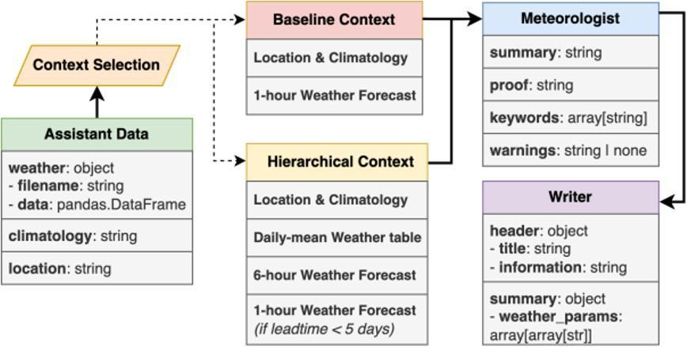
Fig 3.1: Existing System Architecture
The existing system for automated weather report generation follows an agent-based architecture comprising three primary functional components: the Assistant, the Meteorologist, and the Writer. These components operate in a sequential pipeline to transform raw meteorological data into structured, natural-language weather reports. Although the system enables automated generation of weather narratives, it relies heavily on contextual selection and lacks advanced verification mechanisms, causal reasoning capabilities, and robust data validation procedures.
The process begins with the Assistant Data module, which serves as the data preparation component of the system. This module receives meteorological information in the form of structured datasets and is responsible for collecting weather observations, climatological background information, and geographic location details. The assembled dataset includes numerical parameters such as temperature, humidity, atmospheric pressure, and wind speed, which collectively form the basis for generating weather summaries.
Following data collection, the system performs a Context Selection step, which determines the type of contextual representation to be used by the forecasting model. Two distinct context configurations are supported in the existing system: the Baseline Context and the Hierarchical Context.
The Baseline Context provides a simplified representation of prevailing weather conditions. It incorporates information pertaining to the geographic location, regional climatology, and a one-hour weather forecast. This configuration focuses on immediate atmospheric conditions and offers limited temporal coverage. Although it enables the system to generate short-range weather summaries, it does not capture long-term atmospheric patterns or evolving weather trends.
To enhance contextual representation, the system additionally supports a Hierarchical Context structure. This configuration incorporates supplementary layers of meteorological information, including daily mean weather statistics, six-hour weather forecast aggregates, and one-hour forecasts for shorter prediction horizons. The hierarchical context provides a broader temporal view of atmospheric conditions and assists the model in interpreting weather patterns across multiple time scales. However, even with hierarchical aggregation, the system continues to rely primarily on contextual summarisation rather than structured causal reasoning.
Once the appropriate context is constructed, the information is forwarded to the Meteorologist module, which functions as the principal reasoning component of the system. The Meteorologist analyses the selected context and generates a structured output comprising four elements: a weather summary, a proof statement, a list of keywords, and optional warnings. The summary provides a textual description of expected weather conditions; the proof section articulates the reasoning underlying the forecast by referencing numerical weather observations. The keywords highlight significant meteorological indicators -such as rainfall, wind intensification, or temperature fluctuations -while the warnings field is used to flag potential weather hazards when detected.
The structured output produced by the Meteorologist is subsequently passed to the Writer module, which converts the information into a final formatted weather report. The Writer organises the output into a structured document consisting of a header section, a report title, and descriptive information regarding the forecast. Weather parameters and numerical values are additionally formatted into readable tables or structured summaries, facilitating interpretation by end users.
Although the existing system provides a functional framework for automated weather report generation, several notable limitations are evident. The architecture lacks advanced data preprocessing mechanisms, event detection capabilities, and verification layers necessary to ensure the scientific validity of generated forecasts. Furthermore, the system does not explicitly model causal relationships between atmospheric variables, which may result in explanations that lack physical grounding and meteorological coherence. These limitations underscore the necessity for an improved architecture capable of integrating hierarchical modelling, event detection, rule-based validation, and causal reasoning motivating the proposed system described in the subsequent section.

3.1.2 Proposed System Architecture
The proposed system, the Towards Trustworthy AI Meteorology, is implemented as a multi-agent LLM pipeline organized into three sequential execution blocks: Block 1 (Context Preparation / Assistant), Block 2 (Meteorologist Agent - reasoning and verification), and Block 3 (Report Writer). Verification is consolidated into four dedicated verification engines running inside Block 2, coordinated by a confidence scorer, in place of the earlier nine-layer design.
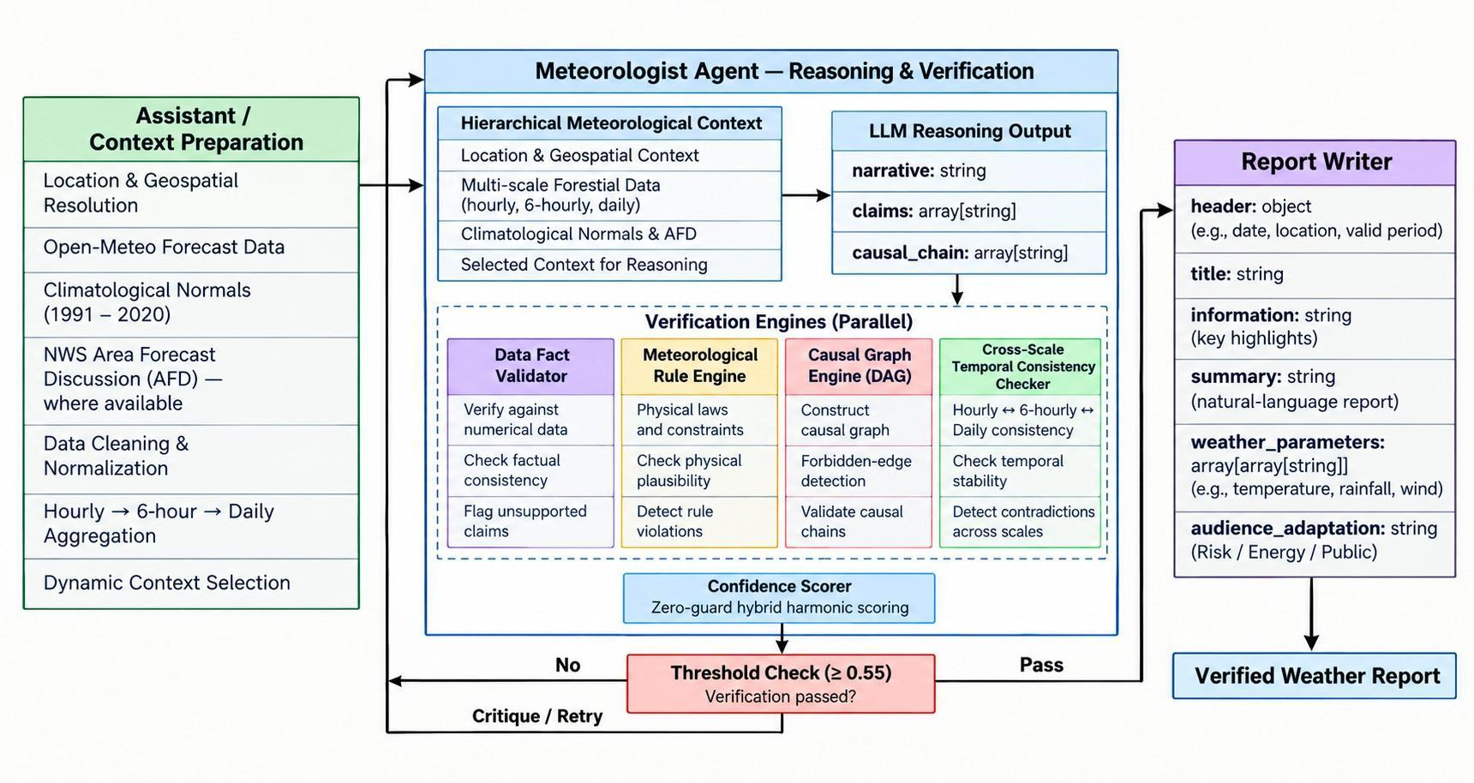
Fig 3.2: Proposed (Implemented) System Architecture
Block 1 - The Assistant (Context Preparation)
Handles the non-deterministic data layer: geospatial resolution of location queries into coordinate-level metadata (including elevation and administrative region), multi-source harvesting of high-resolution forecast data from Open-Meteo and 30-year (1991–2020) climatological normals, and - where available - integration of expert-written NWS Area Forecast Discussions (AFD) for local nuance.
This block also performs hierarchical temporal aggregation: raw hourly data is compressed into 6-hour and daily aggregates using statistical normalization and circular wind analysis, producing 'pre-reasoned' data points that reduce hallucination risk before the data ever reaches the LLM. A dynamic context strategy adjusts payload granularity by forecast lead time (H): full hierarchical context (metadata + climatology + daily + 6-hour + hourly) for lead times under 7 days; a lite hierarchical mode (hourly dropped) beyond 7 days; and a baseline mode (metadata + climatology + full hourly only) for custom queries.
Block 2 - The Meteorologist Agent (Reasoning and Verification)
This is the core research contribution. The orchestration logic lives in run_meteorologist() in app/llm/meteorologist.py. On each run: observational inputs are loaded into Pandas DataFrames (hourly_df, six_hour_df, daily_df, current_df); the Gemini LLM is called to produce a forecast narrative together with a structured list of factual claims and a causal chain; four verification engines are then run against this output; a Confidence Scorer combines their results into a single weighted score; and if that score falls below the acceptance threshold (0.55), the system builds a detailed critique of every failed check, appends it to the prompt, and retries (bounded by max_retry_attempts, which defaults to 0, i.e. one attempt total unless configured otherwise).
Block 3 - The Report Writer
A context-aware formatting agent that polishes the verified narrative into the final structured report. It tailors the output along three axes: target audience domain (General Public, Energy and Grid Operations, Risk and Insurance Analysis, Urban Infrastructure, Agriculture, or Extreme Weather Alerting), tone (Technical, Conversational, or Official Bulletin), and length (Short executive summary, Medium, or Long), while maintaining strict fidelity to the Meteorologist agent's verified findings. For forensic reproducibility, the Writer also emits a provenance lock: a deterministic canonical-JSON SHA-256 fingerprint (context_frozen) of the raw inputs used to generate the report.
The Four Verification Engines (Block 2)
1. Data Fact Validator
Compares every quantitative or comparative claim extracted from the narrative against the actual tabular weather observations. Each claim (validated against the WeatherClaim Pydantic schema) is routed to the correct DataFrame by its data_scale (hourly, six_hour, daily, current, or climatology), time-filtered to its stated window, and its variable name mapped to the correct data column (e.g. temperature → t_c for hourly, t_mean_c/t_min_c/t_max_c for daily). Three assertion types are evaluated: trend claims (a linear-regression slope plus a monotonic step-ratio check, requiring at least 50% of steps to match direction), category-match claims (resolved against thresholds.yaml, requiring at least 50% of observations in-window to fall in range), and threshold-exceeded claims (requiring the condition to hold in at least 25% of observations in the window).
2. Meteorological Rule Engine
Checks whether the claims and causal chain are consistent with 16 deterministic physical conservation rules parsed from met_rules.yaml (e.g. barometric pressure drops preceding convective precipitation, nocturnal radiative cooling, humidity–fog saturation), each specifying expected antecedents, consequents, lag windows, and confidence weights. Rules can fire via two paths: Path A matches antecedent claims by variable, direction, and magnitude (with a 50% magnitude guard against weak or opposite matches), then checks for a consistent consequent claim within the expected lag window (lag − 3.0 h to lag + 6.0 h); Path B matches the same antecedent/consequent relationship against event nodes in the causal chain, restricted to rules with categorical (non-numeric) thresholds. If Path A fires but no consequent claim is present, the engine falls back to Path B before flagging a violation.
3. Causal Graph Engine
Builds a directed acyclic graph (NetworkX DiGraph) of meteorological event relationships from met_rules.yaml, augmented with 14 hand-injected system links (e.g. low_visibility → fog_persistence, pressure_drop → high_humidity) and 5 explicitly forbidden transitions (e.g. dry_air → rainfall, cooling → extreme_heat). validate_chain() checks the LLM's step-by-step causal chain against this graph: any forbidden adjacent pair zeroes the validity score immediately; a direct edge contributes its confidence weight; an indirect path contributes a length-penalized cumulative confidence (multiplying edge confidences and dividing by path length), with any LLM-omitted intermediate nodes logged; and a chain with no path between two nodes scores 0 for that transition.
4. Temporal Consistency Checker
Prevents contradictions between claims made at different observation scales - for example, a daily-level claim of 'clear skies' conflicting with hourly observations of rain. Claims are grouped by scale (daily, six_hour, hourly) and checked pairwise across scale combinations (Daily–6-Hour, 6-Hour–Hourly, Daily–Hourly) for overlapping time windows with opposing asserted directions. High-severity contradictions subtract 1.0 from the consistency score and medium-severity warnings subtract 0.5, giving a final score of max(0, 1 − penalties / total checked scale pairs).
Confidence Scorer
Aggregates the four engines' outputs into a single confidence score using weights from verification_weights.yaml (default: data_fact 0.35, causal_graph 0.20, temporal_consistency 0.20, met_rule 0.10). Three of the four components - data_fact, causal_graph, and temporal_consistency - are combined via a weighted harmonic mean; if any of these three scores is exactly 0, the overall score is zeroed out regardless of the others (a hard zero-guard against critical failures). The met_rule score is then blended in arithmetically to produce the final report, which also ranks all detected issues by severity (high, medium, low) for the retry-feedback loop.
Evaluation Tracker
Logs six metrics per run to .cache/evaluation_log.json for tracking pipeline accuracy over time: False Claim Rate (fraction of claims failing data verification), Cross-Scale Consistency (boolean - no high-severity scale contradictions), Verified Report (boolean - final score ≥ 0.55), Correction Rate (boolean - any high/medium severity failure present), Approximate Hallucination Precision (fraction of failed claims corroborated by a structural rule/graph failure), and Approximate Hallucination Recall .

3.2 Implementation Details

3.2.1 Algorithms / Techniques
- Hierarchical Temporal Aggregation: Pre-processes high-frequency numerical weather prediction series using statistical normalization and circular trigonometric wind analysis (𝑎𝑡𝑎𝑛2), compressing 168-hour data into synoptic 6-hour and daily aggregates to eliminate high-frequency noise.
- Context-Grounded Diagnostic Reasoning: Employs an LLM reasoning engine (Google Gemini series) conditioned on 30-year climatological baselines to synthesize an atmospheric narrative, structured empirical claims, and a chronological causal transition chain in a single inference call.
- Data Fact Validation Engine: Audits quantitative assertions (trends, numerical thresholds, categories, and station-relative temperature anomalies) directly against raw observational time-series DataFrames using ordinary least-squares regression slopes and monotonicity checks.
- Meteorological Rule Engine: Validates atmospheric thermodynamics through a dual-path execution pipeline (claims and causal chain) enforcing 16 physical laws with temporal lag windows, physical measurement tolerances (ϵ), and 50% antecedent magnitude guards.
- Causal Graph Verification: Employs a directed acyclic graph (NetworkX DAG) to validate atmospheric state transitions, applying path-length confidence penalties and enforcing strict mathematical zero-guards on physically forbidden edges (e.g., precipitation forming from dry air).
- Temporal Consistency Auditing: Performs cross-scale pairwise contradiction detection between hourly, 6-hour, and daily claims to prevent contradictory trend assertions within overlapping forecast horizons.
- Deterministic Confidence Scoring with Self-Healing: Aggregates multi-module validation outcomes via a weighted harmonic mean with zero-guards (preventing critical physical violations from being masked by fluent grammar) and triggers an automated Critic-Corrector retry loop when scores fall below threshold.
- Multi-Factorial Scientific Evaluation Framework: Executes systematic evaluation trials across context granularities (hierarchical vs. flat baseline), operational domain personas, linguistic tones, and model variants over a benchmark matrix spanning major global Köppen climate zones; cross-audits verifier rejections against ground-truth hallucinations to yield publication-grade False Claim Rate (𝐹𝐶𝑅) and reliability metrics.

3.2.2 Sequence Diagram
The implementation uses a multi-source context rather than a single weather feed. Forecast observations are obtained from Open-Meteo; historical climatological context is supplied by Meteostat; geospatial metadata is resolved using GeoNames; and NOAA/NWS products, including Area Forecast Discussions where available, provide expert contextual information.The evaluation set spans 52 geographically diverse Indian cities representing 17 distinct climate zones. This coverage allows the verification pipeline to be evaluated across a range of regional weather regimes.
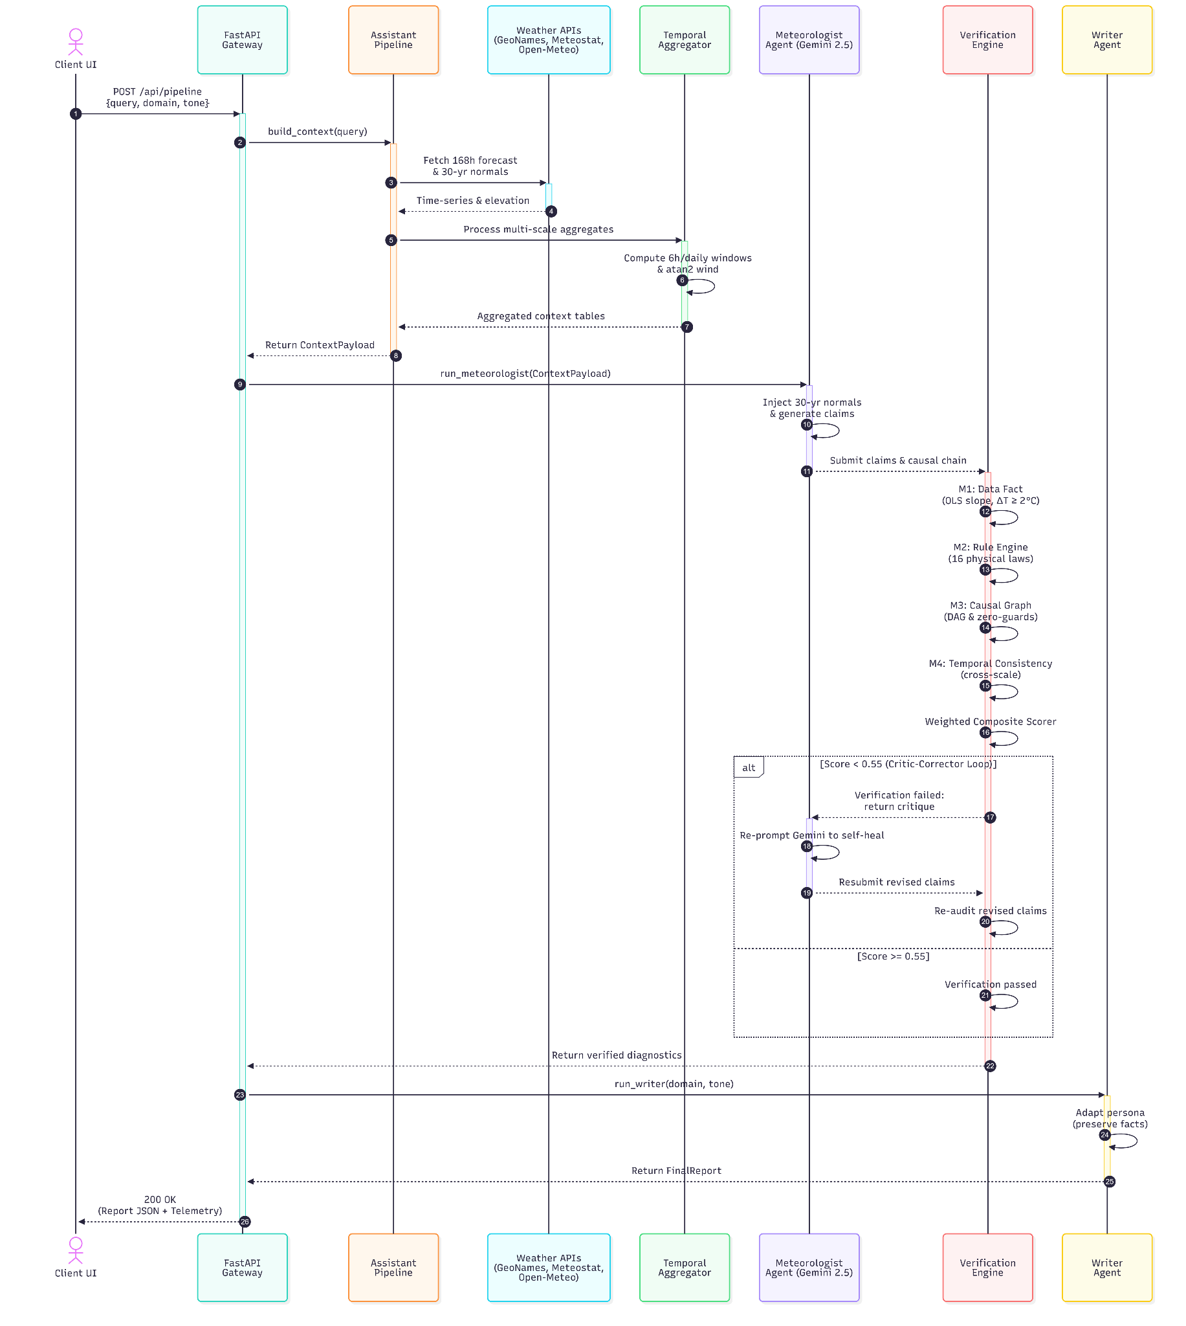
Fig 3.3: Sequence Diagram

Table 3.1: Data Sources and Experimental Evaluation Set
Source / Component | Primary role in the system | Use in reasoning or verification
Open-Meteo | High-resolution forecast variables | Hourly inputs and temporal aggregation
Meteostat | Historical climatological context | Contextual comparison and climatological grounding
GeoNames | Location and geographic metadata | Coordinate, elevation, and administrative context
NOAA / NWS | Expert meteorological context | AFD text and supplementary domain context when available
20 climate-diverse evaluation locations | Experimental coverage | Robustness testing across distinct climate regimes

Table 3.2: Verification Engine Specification
Verification engine | Primary function | Key implementation characteristics
Data Fact Validator | Evidence checking of textual claims | Scale-aware DataFrame routing; trend, category, threshold checks
Meteorological Rule Engine | Physics-based relationship checking | 16 rules; lag windows; magnitude guards; claim and causal paths
Causal Graph Engine | Causal structure validation | NetworkX DAG; valid paths; forbidden-transition detection
Cross-Scale Temporal Consistency Checker | Contradiction detection | Daily-6-Hour, 6-Hour-Hourly, and Daily-Hourly comparisons

3.2.3 Hardware and Software Specifications
- Core logic: Python 3.10+, FastAPI, Pydantic V2
- Intelligence layer: Google Gemini 2.0/2.5 series
- Analytical engines: Pandas, NumPy, NetworkX
- Data services: Open-Meteo, Meteostat, GeoNames, NOAA/NWS
- API interfaces: POST /api/pipeline, /context, /analysis, and /report
- Configuration: GEMINI_API_KEY, GEONAMES_USERNAME, optional CDS_KEY/CDS_URL, CACHE_DIR
Table 3.3: Hardware and Software Specifications
Category | Specification | Purpose / Notes
Processor | Intel Core i7 or AMD Ryzen 7 | Suitable for data preprocessing, API handling, and local experimentation
Memory | 16 GB RAM | Supports concurrent Python, FastAPI, and analysis workloads
Storage | 1 TB SSD | Caches datasets, logs, models, and experiment artifacts
GPU | 6 GB VRAM or better | Optional acceleration for compatible local workloads; not required for API-based Gemini inference
Operating System | Windows 11 / Ubuntu 22.04 LTS | Supported development environments

Chapter 4
Result and Discussion

4.1 Sample of Inputs, Dataset Used, and Outputs

4.1.1 Input Data and Experiment Design
The experimental evaluation of the Hierarchical AI Meteorologist was conducted over a batch of 207 pipeline runs, covering 52 geographically diverse Indian cities spanning seventeen distinct climate zones, from tropical monsoon (Mumbai) and hot desert (Jodhpur) to subtropical highland (Darjeeling, Shillong) and cold desert alpine (Leh). Each city was run four times with different tone and domain settings (three for one city). This breadth was chosen deliberately to stress-test the verification engine across varying atmospheric regimes, each of which exercises different subsets of the sixteen meteorological rules encoded in the system.
Each run was configured with a combination of three user-facing parameters: tone (technical, conversational, or official), domain (risk analysis, general public, agriculture, or extreme weather), and report length (short). Weather data was fetched in real time from the Open-Meteo API, with climatological baselines from the Meteostat climate normals dataset (1991-2020). Where Meteostat returned no data, the system fell back to Copernicus ERA5 monthly averages. All 207 runs employed the hierarchical context style, which supplies the Gemini LLM with hourly, six-hour, and daily aggregate tables simultaneously, enabling multi-scale reasoning.
The primary LLM was Gemini 3 Flash Preview (206 runs), with one early calibration run using the older Gemini 2.5 Flash Lite model. All runs were executed between 14 September and 5 October 2026 without manual intervention through an automated batch runner on GitHub Actions, and results were stored in a PostgreSQL database hosted on Supabase.

4.1.2 Pipeline Outputs
For each pipeline run, the system produced three categories of outputs:
- Structured Meteorological Analysis - Generated by Block 2 (Meteorologist Agent): a weather summary, a proof section, three to five keywords, up to eight structured weather claims, and a causal chain of four to eight meteorological events. Each claim specifies a weather variable, an assertion type (threshold, trend, or category), a data scale, and a time window.
- Verification Report - Produced by the four-module verification engine: per-claim fact-check results, rule-engine output, causal graph validation results, and temporal consistency results. These four sub-scores are aggregated into a single overall confidence score through a weighted harmonic mean.
- Final Weather Report - Generated by Block 3 (Writer Agent), adapting the verified analysis into a reader-facing narrative in the requested tone and domain, with a frozen copy of the input context for reproducibility.

4.1.3 Dataset Summary
For a typical run, the pipeline ingested between 48 and 168 hourly observations (two to seven days of data), aggregated into six-hour windows and daily summaries. The variables included temperature (°C), relative humidity (%), mean sea level pressure (hPa), precipitation sum (mm), wind speed (m/s), wind direction (degrees), dew point temperature (°C), and visibility (metres), which directly fed the fact-checking and rule-evaluation modules.

4.2 Evaluation Parameters
Rather than relying on a single accuracy metric, the system produces a composite confidence score from four independent verification modules, each targeting a distinct aspect of forecast quality.

4.2.1 Component-Level Scores
Fact Validation Score (S_{f}): The fraction of structured weather claims that passed data-level fact-checking against observed records. Threshold claims (such as "temperature greater than 30 degrees Celsius") pass if at least 25 percent of observations in the claimed window satisfy the condition. Trend claims are validated using linear regression slope direction and a monotonic step ratio, requiring at least 50 percent of consecutive steps to move in the asserted direction.
Rule Consistency Score (S_{r}): The adherence of the LLM output to established meteorological cause-and-effect relationships. The rule engine loads sixteen physical rules from met_rules.yaml, each with an antecedent (for example, a six-hour pressure drop exceeding 3.0 hPa), a consequent (for example, wind speed exceeding 8.0 m/s), a temporal lag, and a confidence weight. A rule fires when its antecedent appears in the claims or causal chain, and the score is the weighted fraction of fired rules whose consequences are satisfied.
Causal Graph Validity Score (S_{c}): Assesses whether the LLM’s causal chain represents plausible atmospheric transitions. A directed graph is built from the sixteen rules and twelve supplementary system-injected edges. Direct edges receive their configured confidence weight, indirect paths receive the product of edge confidences divided by path length, and forbidden transitions (such as "dry air leading to rainfall") immediately zero the entire causal score.
Temporal Consistency Score (S_{t}): Detects directional contradictions across time scales. Overlapping claims on the same variable at different scales (daily, six-hour, hourly) that assert opposite trends are flagged as high-severity contradictions. The score is one minus the ratio of accumulated penalty to the number of cross-scale pairs examined.

4.2.2 Composite Confidence Score
The fact, causal, and temporal scores are first combined through a weighted harmonic mean:
S_{base} = (w_{f} + w_{c} + w_{t}) / (w_{f}/S_{f} + w_{c}/S_{c} + w_{t}/S_{t})
where w_{f} = 0.35, w_{c} = 0.20, and w_{t} = 0.20. The harmonic mean enforces a strict zero-guard: if any one of the three core modules returns zero, the base score collapses to zero, so a single critical failure (such as a forbidden causal edge) cannot be masked by strong performance elsewhere. The rule score is then combined arithmetically:
overall_score = (S_{base} × (w_{f} + w_{c} + w_{t}) + S_{r} × w_{r}) / (w_{f} + w_{c} + w_{t} + w_{r})
where w_{r} = 0.10. A run is classified as a "verified report" if its overall score meets or exceeds the verification threshold of 0.55.

4.2.3 Derived Metrics
- False Claim Rate (FCR): The fraction of total claims that failed fact-checking against the observed data.
- Hallucination Precision: The fraction of failed fact claims corroborated by at least one rule violation or causal failure.
- Hallucination Recall: The fraction of rule violations that were also captured by a fact-level failure.
- Correction Needed: A binary flag indicating whether the confidence score fell below threshold, signalling that re-generation is needed.
- Pipeline Latency: Total end-to-end execution time in milliseconds, split into assistant (data ingestion), meteorologist (LLM generation plus verification), and writer phases.

4.3 Performance Evaluation

4.3.1 Overall System Performance
The Hierarchical AI Meteorologist achieved strong results across the 207 runs. The mean overall confidence score was 0.8813, and the 0.55 verification threshold was exceeded in 206 out of 207 runs, a verified report rate of 99.5 percent. The single run below the threshold was the early calibration run on Gemini 2.5 Flash Lite, which scored 0.3252, attributable to the smaller model’s limited capacity for structured meteorological reasoning.
The temporal consistency module returned a score of 1.0 in all 207 runs, so no cross-scale directional contradictions were detected. It should be noted, however, that the module found overlapping claims on the same variable at different scales in only 5 of the 207 runs; in the remaining runs there was nothing to compare, so the score defaults to 1.0. The result therefore shows that the generated reports did not contradict themselves across scales, but it is not strong evidence on its own that the hierarchical context design prevents such contradictions.
Table 4.1: Aggregate Verification Scores Across 207 Pipeline Runs
Metric | Mean | Std. Dev. | Min | Max
Verification scores (0–1)
Overall confidence score, S_{overall} | 0.8813 | 0.0724 | 0.3252 | 0.9528
Fact validation score, S_{f} | 0.9678 | 0.1071 | 0.3750 | 1.0000
Rule consistency score, S_{r} | 0.9565 | 0.2044 | 0.0000 | 1.0000
Causal graph validity score, S_{c} | 0.6843 | 0.0821 | 0.0758 | 0.8250
Temporal consistency score, S_{t} | 1.0000 | 0.0000 | 1.0000 | 1.0000
Claim-level metrics
Claims generated per run | 6.33 | 0.99 | 5.00 | 8.00
Failed claims per run | 0.20 | 0.67 | 0.00 | 5.00
False claim rate | 0.0322 | 0.1071 | 0.0000 | 0.6250
Run-level outcomes
Verified reports (S ≥ 0.55) | 99.5% | 206 of 207 runs
Cross-scale consistent reports | 100.0% | 207 of 207 runs
End-to-end pipeline latency (s)
Total pipeline time | 95.4 | 70.0 | 12.0 | 294.7

4.3.2 Component-Level Analysis
Fact Validation. The module recorded a mean score of 0.9678, with 90 percent of runs (186 of 207) achieving a perfect 1.0. The mean false claim rate of 3.22 percent means that fewer than one claim per run (0.20 out of 6.33) failed fact-checking, which is encouraging given the validator’s strict 25 percent support threshold. Of the 41 claims that failed, 24 failed because the validator could not locate the referenced variable in the data table (for example, a daily-scale pressure claim written with a different column name). These reflect a variable-mapping limitation rather than fabricated values, so the true unsupported-claim rate is lower than the reported figure.
Rule Consistency. The rule engine returned a mean score of 0.9565, with 95.7 percent of runs (198 of 207) achieving perfect consistency. Nine runs (4.3 percent) scored zero, meaning a fired rule had its consequent entirely unsatisfied, yet the average was only 0.04 violations per run. A rule contributes only when its antecedent is matched, and no rule fired in 178 of the 207 runs. The score is therefore based on the 29 runs in which at least one rule was actually tested, nine of which failed.
Causal Graph Validity. This module showed the most variation (mean 0.6843, range 0.0758 to 0.8250), and no run achieved a perfect score. The most common issue was “missing intermediate” warnings, which appeared in 169 of the 207 runs, where the chain skipped expected steps (for example, “pressure drop” directly to “rainfall” without “high humidity”). The second was “unlinked transitions”, where adjacent events had no edge or path in the reference graph; these were rare, occurring in only 5 runs. The lower scores do not necessarily indicate factual inaccuracy; they reflect a gap between the LLM’s compressed reasoning style and the engine’s expectation of a step-by-step chain, so this module tests explanatory rigour rather than predictive accuracy.
Temporal Consistency. The score of 1.0 across all 207 runs indicates that no directional contradictions were produced across temporal resolutions. However, overlapping claims on the same variable at different scales were present in only 5 of the 207 runs, so in most runs there was nothing to compare and the score defaults to 1.0. The result therefore supports the scale-aware context construction only weakly, and a targeted test with more cross-scale claims would be needed to confirm it.

4.3.3 Performance Across Climate Zones and Configuration Variants
Table 4.2: Overall Confidence Score by Climate Zone
Climate Zone | Runs | Mean Score | Std. Dev. | Min Score | Max Score
Tropical Monsoon (Extreme Wet) † | 4 | 0.9228 | 0.0258 | 0.9004 | 0.9528
Subtropical Highland | 28 | 0.9133 | 0.0291 | 0.8284 | 0.9528
Tropical Savanna (Coastal) | 16 | 0.9063 | 0.0257 | 0.8618 | 0.9449
Tropical Monsoon (Coastal) | 16 | 0.8993 | 0.0372 | 0.7952 | 0.9449
Hot Semi-Arid (Coastal) † | 4 | 0.8992 | 0.0273 | 0.8626 | 0.9286
Cold Alpine † | 3 | 0.8980 | 0.0033 | 0.8943 | 0.9004
Hot Semi-Arid | 20 | 0.8975 | 0.0243 | 0.8454 | 0.9449
Humid Subtropical (Highland) † | 4 | 0.8957 | 0.0131 | 0.8761 | 0.9032
Tropical Rainforest (Island) † | 4 | 0.8955 | 0.0133 | 0.8843 | 0.9117
Tropical Highland † | 4 | 0.8902 | 0.0525 | 0.8114 | 0.9165
Cold Desert Alpine † | 4 | 0.8783 | 0.0669 | 0.7852 | 0.9304
Tropical Wet-Dry | 24 | 0.8772 | 0.0754 | 0.6148 | 0.9449
Tropical Savanna | 16 | 0.8755 | 0.0455 | 0.7818 | 0.9250
Hot Desert | 16 | 0.8745 | 0.0426 | 0.7491 | 0.9287
Humid Subtropical | 36 | 0.8669 | 0.0815 | 0.6200 | 0.9449
Tropical Savanna (Highland) † | 4 | 0.7701 | 0.1221 | 0.5940 | 0.8731
Tropical Monsoon † | 4 | 0.6133 | 0.1964 | 0.3252 | 0.7654
All zones | 207 | 0.8813 | 0.0724 | 0.3252 | 0.9528

The lowest-performing zone was tropical monsoon (Mumbai; mean 0.6133), pulled down by the Gemini 2.5 Flash Lite calibration run (0.3252). Even excluding it, Mumbai’s three remaining scores (0.7654, 0.6941 and 0.6684; mean 0.7093) were below the dataset average of 0.8813, likely due to complex coastal-monsoon dynamics, including sea breeze interactions, urban heat island effects, and convective variability, that are harder to distill into a clean causal chain. The tropical savanna (highland) zone was also low (mean 0.7701).

4.3.4 Claims and Hallucination Analysis
The system generated an average of 6.33 structured claims per run, of which 0.20 (3.22 percent) failed fact-checking. The hallucination precision was 0.02 and the recall was 0.005, both very low. This is expected in a well-performing system: when both fact failures and rule violations are rare, there are very few failures for the modules to agree on, so the cross-correlation approaches zero. The 15.0 percent correction-needed rate (31 of 207 runs) indicates that while most runs pass comfortably, roughly one in seven contains at least one aspect, typically a structural causal chain gap, flagged for potential improvement.

4.3.5 Pipeline Latency
The average end-to-end latency was 95.4 seconds (median 80.3 seconds), ranging from 12.0 to 294.7 seconds. On average, the data-assistant stage (data acquisition and aggregation) took 61.7 seconds, the meteorologist stage 22.3 seconds and the writer stage 11.3 seconds, so latency was dominated by data retrieval rather than LLM generation. The fastest run was the smaller Gemini 2.5 Flash Lite calibration. For a batch system these latencies are acceptable; for production, the caching layer and the option to limit the hourly window to 24 rows would reduce typical latencies.

4.3.6 Discussion
The results show that the four-module verification engine enforces factual accuracy and rule adherence in LLM-generated weather reports, and that no cross-scale contradictions were detected. The mean confidence score of 0.8813 and the 99.5% verified report rate indicate that most outputs passed the implemented verification threshold under the tested conditions. These results demonstrate the pipeline's ability to assess generated reports against its configured checks, but do not independently establish forecast accuracy or readiness for safety-critical deployment.
The causal graph module, with the lowest mean (0.6843), checks whether the explanation of atmospheric dynamics is structurally complete, not whether the forecast is correct. The gap between causal and fact scores shows that the LLM produces accurate predictions with compressed causal reasoning. The tone and domain settings had little effect on scores: mean scores across the four tone and domain combinations differed by at most 0.015 (0.8759 to 0.8911), which suggests that the engine decouples content accuracy from stylistic variation. In the experiment each tone was paired with fixed domains, so the separate effect of tone and of domain cannot be isolated.
The nine runs with zero rule scores warrant further investigation, as they may stem from genuine LLM errors or overly strict rule margins; further margin tuning may improve the rule module without introducing false positives. Because rules fired in only 29 of the 207 runs, a broader set of test conditions would also be needed to exercise the rule engine more fully. Overall, the results support the core hypothesis of this project: a multi-module, physics-informed verification engine can improve the trustworthiness of LLM-generated weather reports by catching hallucinations before they reach the end user.

Chapter 5
Impacts

5.1 Impact on the Real World
The development of the Towards Trustworthy AI Meteorology framework carries significant implications for how weather information is generated, verified, and communicated across multiple domains. By addressing fundamental limitations in existing AI-based forecasting systems - namely the absence of verification mechanisms, the lack of causal reasoning, and the gap between numerical outputs and human-readable explanations the proposed system introduces a paradigm shift in automated meteorological reporting. The following sections outline the anticipated real-world impact of the framework across societal, technological, environmental, economic, and academic dimensions.

5.2 Societal Impact
Weather information directly influences the daily decisions of billions of individuals worldwide. However, the growing integration of Large Language Models into information systems has raised concerns regarding the reliability of AI-generated content, particularly in safety-critical domains such as meteorology. The proposed framework addresses this concern by embedding a four-module verification engine that cross-validates every LLM-generated statement against observed meteorological data before it reaches the end user. This architectural design ensures that weather reports delivered to the public are not only readable but also factually grounded, thereby reducing the risk of misinformation during weather-sensitive events such as monsoons, cyclones, or heat waves.
Furthermore, by generating weather narratives in accessible natural language rather than presenting raw numerical tables, the system lowers the barrier to understanding meteorological information for non-expert populations. Farmers in rural communities, small business owners, and individuals without technical training can benefit from weather reports that clearly explain atmospheric conditions and their expected progression. This democratisation of weather knowledge has the potential to improve preparedness and reduce weather-related losses in vulnerable communities, particularly in developing regions where access to professional meteorological interpretation is limited.

5.3 Technological Impact
From a technological standpoint, the framework demonstrates that structured verification pipelines can be integrated into LLM-based generation systems without requiring model fine-tuning or retraining. The four independent verification modules - Data Fact Validation, Meteorological Rule Engine, Causal Graph Validation, and Temporal Consistency Checking - operate as post-generation quality gates that can be adapted to other domains beyond meteorology. This modular verification architecture establishes a reusable design pattern for any application where AI-generated text must be validated against structured data sources, including healthcare reporting, financial analysis, and legal document generation.
The system also contributes to the broader discourse on AI trustworthiness by providing a concrete implementation of hallucination detection in domain-specific LLM applications. The use of a weighted harmonic mean for confidence scoring, combined with a zero-tolerance policy for physically impossible causal transitions, represents a rigorous approach to output quality control that can inform the design of verification systems in other safety-critical AI applications. Additionally, the hierarchical temporal aggregation methodology - processing weather data across hourly, six-hourly, and daily scales - offers a transferable technique for any time-series interpretation task requiring multi-resolution analysis.

5.4 Environmental and Climate Impact
Accurate and interpretable weather information plays a critical role in environmental monitoring and climate adaptation strategies. The proposed system can support environmental agencies in communicating weather patterns and anomalies to the public and to policymakers in a format that facilitates informed decision-making. By generating verified, explainable weather narratives from publicly available meteorological data sources such as Open-Meteo and Meteostat, the framework enables continuous environmental surveillance without dependence on proprietary forecasting infrastructure.
In the context of climate change, the increasing frequency and intensity of extreme weather events necessitate robust communication systems that can rapidly translate atmospheric observations into actionable information. The causal reasoning capabilities embedded within the framework - linking pressure changes to wind intensification, humidity patterns to precipitation likelihood, and temperature anomalies to broader atmospheric trends - enable the system to provide scientifically coherent explanations of evolving weather situations. This capability is particularly valuable for climate resilience planning, where understanding the causal chain of meteorological events is essential for designing effective adaptation measures.

5.5 Economic Impact
Weather-dependent industries such as agriculture, energy, transportation, logistics, and construction collectively account for a substantial portion of global economic activity. Inaccurate or poorly communicated weather forecasts can result in significant financial losses through crop damage, energy grid instability, supply chain disruptions, and infrastructure failures. The proposed system mitigates these risks by ensuring that weather reports provided to industry stakeholders are verified against actual meteorological observations and are consistent across multiple temporal scales.
For the renewable energy sector specifically, the ability to generate reliable forecasts of wind speed, solar radiation proxies, and temperature trends directly supports operational planning for wind farms and solar installations. The domain-adaptive Writer module, which can tailor reports for energy professionals, further enhances the practical utility of the system. By reducing reliance on manual meteorological interpretation and providing automated, verified weather intelligence, the framework has the potential to lower operational costs and improve resource allocation across weather-sensitive economic sectors.

5.6 Academic and Research Impact
The project contributes to the academic discourse on trustworthy AI by presenting a working implementation of a multi-layered verification architecture for LLM-generated content. The four-module verification engine, the 16-rule meteorological knowledge base, the causal event graph with forbidden-edge detection, and the cross-scale temporal consistency checker collectively represent novel contributions to the intersection of artificial intelligence, natural language processing, and atmospheric science.
The experimental evaluation, conducted across 207 pipeline runs covering 52 Indian cities and 17 distinct climate zones, achieved a mean verification confidence score of 0.8813. A total of 206 runs (99.5%) met or exceeded the configured verification threshold of 0.55, while the mean false claim rate was 3.22%. These results demonstrate the potential of structured verification mechanisms to assess the factual and structural consistency of LLM-generated weather reports. However, the scores represent the behaviour of the implemented verification pipeline and should not be interpreted as independent proof of forecast accuracy or complete elimination of hallucinations.

Moreover, the open-source, modular design of the system - built on publicly available APIs and standard Python libraries - enables reproducibility and extensibility by other research groups. The framework can serve as a foundation for further investigations into areas such as multi-modal weather reasoning, reinforcement learning-based forecast refinement, and the integration of satellite imagery with textual weather analysis.

Chapter 6
Summary
This report presents the design and development of the Towards Trustworthy AI Meteorology, which aims to generate explainable and consistent weather reports from structured meteorological data. Traditional weather forecasting systems primarily produce numerical outputs that can be difficult for non-experts to interpret. The proposed system addresses this limitation by converting meteorological observations into clear natural language forecasts while ensuring factual consistency and logical reasoning.
The study explores several techniques including hierarchical temporal aggregation of weather data, natural language generation using Large Language Models, rule-based weather event detection, and verification mechanisms for validating generated forecasts. These techniques allow the system to analyze atmospheric variables such as temperature, pressure, humidity, wind speed, and precipitation across multiple temporal scales including hourly, six-hourly, and daily observations.
A key contribution of the proposed framework is the inclusion of verification and reasoning mechanisms that evaluate whether the generated weather narratives are consistent with the underlying meteorological data and known atmospheric relationships. By combining data-driven analysis with rule-based validation and causal reasoning, the system improves the reliability and interpretability of automated weather reports.
The system was evaluated using component-level verification scores, false claim rate, approximate hallucination precision and recall, cross-scale consistency, verified report rate, and pipeline latency. Across 207 pipeline runs covering 52 Indian cities and 17 climate zones, the mean overall confidence score was 0.8813, and 206 runs (99.5%) met the configured verification threshold. The mean false claim rate was 3.22%. These results characterize the behaviour of the implemented verification pipeline; further evaluation against independently labelled weather events and observed outcomes is needed to establish predictive accuracy and generalisation.
Overall, the proposed system demonstrates how artificial intelligence and natural language processing techniques can enhance meteorological reporting by transforming complex numerical data into understandable and trustworthy weather forecasts. This approach can support decision-making in various sectors such as agriculture, disaster management, urban planning, and energy management, while also improving public access to weather information.
References
[1] Z. Zhou et al., "Omni-Weather: A Unified Multimodal Model for Weather Radar Understanding and Generation," arXiv preprint arXiv:2512.21643, Mar. 2026.
[2] K. Wu et al., "Weather-R1: Logically Consistent Reinforcement Fine-Tuning for Multimodal Reasoning in Meteorology," arXiv preprint arXiv:2601.14044, Jan. 2026.
[3] M. S. Pavithran et al., "Multi-Scale Weather Forecasting Using Deep Learning Architectures with Chennai Climate Data," IEEE Access, vol. 13, Dec. 2025.
[4] M. Dubovitsky et al., "Hierarchical AI-Meteorologist: LLM-Agent System for Multi-Scale and Explainable Weather Forecast Reporting," arXiv preprint arXiv:2511.23387, Nov. 2025.
[5] K. B. Arifani et al., "Real-Time Data Integration and Weather Reporting Automation with Cloud Computing-based Interactive Spatial Dashboard for Extreme Weather Risk Analytics in Indonesia," Journal of Computer Networks, Architecture and High Performance Computing, vol. 7, no. 3, Jul. 2025.
[6] Y. Luo, Y. Zhou, M. Cheng, et al., "Time Series Forecasting as Reasoning: A Slow-Thinking Approach," arXiv preprint arXiv:2506.10630, Jun. 2025.
[7] J. Tang, S. Chen, C. Gong, J. Zhang, and D. Tao, "LLM-PS: Empowering Large Language Models for Time Series Forecasting with Temporal Patterns and Semantics," arXiv preprint arXiv:2503.09656, Mar. 2025.
[8] M. S. Jahangir and J. Quilty, "Hierarchical Deep Learning for Consistent Multi-Timescale Hydrological Forecasting," Water Resources Research, vol. 61, 2025.
[9] S. An et al., "Deep Learning for Precipitation Nowcasting: A Survey from the Perspective of Time Series Forecasting," arXiv preprint, Jan. 2025.
[10] B. Ghosh et al., "Logical Consistency of Large Language Models in Fact-Checking," arXiv preprint arXiv:2412.16100, Dec. 2024.
[11] Y. Wang and H. A. Karimi, "Exploring Large Language Models for Climate Forecasting," arXiv preprint arXiv:2411.13724, Nov. 2024.
[12] H. Li et al., "CLLMate: A Multimodal LLM for Weather and Climate Events Forecasting," arXiv preprint arXiv:2409.19058, Sep. 2024.
[13] B. Li and Y. Qian, "Weather Prediction Using CNN-LSTM for Time Series Analysis: A Case Study on Delhi Temperature Data," arXiv preprint arXiv:2409.09414, Sep. 2024.
[14] M. Jin et al., "TIME-LLM: Time Series Forecasting by Reprogramming Large Language Models," arXiv preprint arXiv:2310.01728, Oct. 2023.
[15] C. Chang et al., "LLM4TS: Two-Stage Fine-Tuning for Time-Series Forecasting with Pre-Trained LLMs," arXiv preprint arXiv:2308.08469, Aug. 2023.
A Systematic Review on LLM-Agent Systems for Multi-Scale Weather Forecasting
Dr. Dhiraj Amin  Department of Computer Engineering  Pillai College of Engineering  Navi Mumbai, India  amindhiraj@mes.ac.in | Krish Vinod  Department of Computer Engineering  Pillai College of Engineering  Navi Mumbai, India  kvinod23comp@student.mes.ac.in | Parth Ghadge  Department of Computer Engineering  Pillai College of Engineering  Navi Mumbai, India  gparth23comp@student.mes.ac.in
Abinraj P Lalraj  Department of Computer Engineering  Pillai College of Engineering  Navi Mumbai, India  pabinaraj23comp@student.mes.ac.in | Adithya Saji Kumar  Department of Computer Engineering  Pillai College of Engineering  Navi Mumbai, India  asaji23comp@student.mes.ac.in | Prof. Neha Ashok  Department of Computer Engineering  Pillai College of Engineering  Navi Mumbai, India  ashokneha@mes.ac.in

Abstract-Accurate meteorological reporting is critical for decision-making in sectors such as agriculture, disaster risk management, aviation, and public safety. Although advances in numerical weather prediction and Large Language Models (LLMs) have improved automated forecasting, generating reliable and explainable weather reports remains challenging due to hallucinations, numerical reasoning errors, and temporal inconsistencies. Despite growing interest in this area, a comprehensive survey of explainable LLM-agent systems for automated meteorological reporting is still lacking. This systematic literature review examines 34 primary studies published between 2023 and 2026 and organizes the literature into four research areas: (1) data preprocessing, (2) multi-scale representation and alignment, (3) multi-agent orchestration, and (4) logical consistency controls. We present a taxonomy of existing approaches, identify key challenges including factual inconsistency, causal hallucinations, temporal contradictions, and external knowledge dependency, and synthesize the verification strategies used across these studies to highlight the architectural gaps that future hallucination-aware weather-reporting systems will need to address. Finally, we discuss open challenges and future directions toward reliable, explainable, and trustworthy LLM-agent systems for automated weather reporting.
Keywords - LLM-agent systems, weather forecasting, hallucination mitigation, multi-agent orchestration, logical consistency, explainable AI, meteorological reporting.
I. INTRODUCTION
Operational weather forecasting serves as a cornerstone of modern risk management, emergency preparedness, and socio-economic planning. For decades, the atmospheric science community has relied on traditional numerical weather prediction (NWP) systems and, more recently, state-of-the-art deep learning surrogates to generate global and regional projections [20]. While these systems excel at outputting high-dimensional numerical tables and gridded atmospheric tensors with impressive precision, their raw outputs are fundamentally alienated from human-readable formats [23]. This creates a critical meteorological interpretation gap [23]. Human forecasters and decision-makers require more than mathematical variables; they demand coherent, causally consistent narratives, contextualised hazard warnings, and region-specific explanations to make high-stakes operational choices [23][15].
Recent developments in deep learning, Large Language Models (LLMs), Vision-Language Models (VLMs), and multi-agent architectures have opened up promising pathways to bridge this interpretation gap [31][32]. By integrating advanced natural language processing with robust spatiotemporal pattern recognition, these models can act as intelligent 'AI meteorologists' [33][6]. This shift from static numerical translation to active, tool-augmented reasoning allows AI systems to ingest multivariate time series, verify physical hypotheses, and generate human-readable reports grounded in verifiable physical evidence [23][33].
This emerging research landscape displays rapid diversification. A primary direction focuses on cross-modality reprogramming, mapping continuous time-series patches onto discrete text prototypes so frozen LLMs can execute forecasting tasks [2]. A second direction establishes multimodal semantic alignment, training vision-language decoders to predict textual weather and climate events directly from gridded meteorological rasters [6]. A third paradigm deploys modular multi-agent orchestration, decomposing complex workflows into specialized collaborative nodes-such as data specialists, code executors, and visual checkers-that communicate over RESTful pipelines [23][33]. Finally, researchers are optimizing the internal logical weight alignment of these models through supervised fine-tuning and reinforcement learning from joint consistency rewards [31][8].
However, applying general-purpose models to high-stakes meteorology exposes several fundamental challenges. First, standalone LLMs exhibit a numerical reasoning limitation when processing tabular meteorological data; standard subword tokenizers split multidigit values arbitrarily, causing severe numerical hallucinations [32][2]. Second, when exposed to long context horizons containing high-frequency hourly weather rows, LLMs suffer from positional attention bias and context degradation, often 'forgetting' critical short-range anomalies [23][29]. Third, multi-step chains of thought are highly vulnerable to cascading error propagation [29]. Most critically, models frequently suffer from 'self-contradictory reasoning' (Self-Contra), generating correct physical justifications in their thinking chains but selecting incorrect final warning outputs [31]. Furthermore, evaluation remains highly fragmented, lacking open-source, standardized benchmarks to verify explanation quality [33][6].
To resolve these discrepancies, this survey provides a systematic quantitative performance synthesis of the domain. While traditional reviews focus on pure deep learning surrogates, they omit natural language synthesis and agentic reasoning [4]. Conversely, general computer science surveys ignore the physical and logical consistencies required by atmospheric sciences [8]. There is an urgent need to organize these fragmented methodologies under a unified taxonomy, synthesize their processing steps into a common research pipeline, and analyze their reported quantitative results to establish a trustworthy roadmap.
The scope of this survey examines 34 primary studies published at the interface of geoscientific data discovery, time-series reasoning, and multi-agent systems [23][22][2]. Rather than proposing a new model, the major contributions of this survey are synthesis-oriented: we propose a multi-tiered Atmospheric Interpretation Taxonomy classifying the literature across four structural pillars; we synthesize the Common Meteorological AI Pipeline; we present a representative comparison matrix; we conduct a systematic quantitative performance synthesis; we trace the research evolution of atmospheric modeling; and we outline an evidence-based future roadmap.
The remainder of this survey is organized logically. Section II details our systematic literature review methodology, including data sources, eligibility criteria, and screening results. Section III provides the technical and historical background of weather forecasting and language model integration. Section IV establishes our formal research taxonomy across four pillars. Section V presents a comprehensive literature review and introduces the unified data-to-text pipeline alongside a detailed comparison matrix of reviewed works. Section VI conducts our comparative analysis of continuous and discrete orchestration paradigms. Section VII presents systematic quantitative performance results from geoscientific and logical benchmarks. Section VIII synthesizes cross-cutting cognitive challenges and unresolved research gaps, followed by Section IX, which concludes the survey, and Section X, which presents the master bibliography.
II. SYSTEMATIC REVIEW METHODOLOGY
2.1 Literature Search Strategy and Data Sources
To ensure a comprehensive and reproducible review of modular Large Language Model (LLM) agent frameworks and their application in meteorological forecasting and interpretation, we conducted a systematic literature search up to 2026, restricted to the search window of August 1, 2023 to August 16, 2026. We queried four primary academic databases: arXiv, IEEE Xplore, ScienceDirect (Elsevier), and Wiley Online Library (Water Resources Research) [33][8][4]. The search queries were designed to target the intersection of generative artificial intelligence and geoscientific modeling. Specifically, we applied the following Boolean search string: ("Large Language Model" OR "LLM" OR "AI Agent" OR "Multi-Agent System" OR "Foundation Model") AND ("weather" OR "meteorology" OR "precipitation nowcasting" OR "time series reasoning" OR "fact-checking" OR "climate forecasting") [31][20][2].
2.2 Inclusion and Exclusion Criteria
Studies retrieved from the initial database searches were evaluated against strict eligibility criteria to filter out irrelevant or scientifically unverified content. A study was included in this systematic review if it satisfied the following three conditions: (1) it proposed, analyzed, or validated modular LLM agent systems, vision-language models (VLMs), or time-series reprogramming frameworks for environmental, hydrological, or meteorological forecasting and interpretation [23][22][2]; (2) it addressed at least one relevant challenge in geoscientific data-to-text processing, multimodal alignment, temporal consistency, reasoning, physical correctness, logical consistency, or agentic workflow design [33][31]; and (3) it was published as a peer-reviewed journal article, conference proceeding, or verified archive preprint between 2023 and 2026.
Conversely, we excluded studies that met any of the following criteria: (1) studies employing standard, non-semantic deep learning architectures (such as standalone LSTMs or CNNs) without incorporating natural language processing, semantic representation alignment, or agentic planning [24]; and (2) research focusing solely on numerical weather prediction without proposing explanation, explanation validation, or text-based report-generation interfaces. Purely numerical forecasting studies were excluded unless they contributed a transferable mechanism for temporal consistency, multiscale alignment, or another methodological component directly relevant to the review; such studies are marked as Adjacent in Table I.
2.3 Study Selection and Screening Process
The screening process followed the PRISMA (Preferred Reporting Items for Systematic Reviews and Meta-Analyses) protocol to ensure methodological rigor across four stages: identification, screening, eligibility, and inclusion. Title/abstract screening, full-text eligibility assessment, and data extraction were performed by two reviewers, with the remaining team members contributing to discussion and verification. Any disagreements were resolved through discussion and consensus among the team members. For each eligible study, a standardized extraction form recorded the meteorological data source, reasoning/model architecture, hallucination-handling strategy, and evaluation metrics. In the identification stage, 233 records were retrieved across four electronic databases (arXiv, IEEE Xplore, ScienceDirect, and Wiley Online Library) using the Boolean search string described above. After removing 70 duplicate records, 163 articles remained for title and abstract screening against the inclusion/exclusion criteria; 86 records were excluded as out-of-scope. The remaining 77 full-text articles were assessed against four binary Quality Assessment (QA) criteria, each scored 1 (clearly reported) or 0 (not clearly reported): (QA1) the meteorological data source is clearly described; (QA2) the reasoning or model architecture is clearly described; (QA3) hallucination-handling or logical-consistency handling is clearly described; and (QA4) evaluation metrics are clearly reported. Inclusion required a study to satisfy all four criteria (QA score of 4/4); of the 77 full-text articles drawn from the four databases, 40 studies failing at least one criterion were excluded at this stage, leaving 37 studies passing QA. Separately, from outside the 233 database records, 3 grey-literature records were identified and subsequently excluded. Combining these two populations yielded exactly 34 primary studies that consistently form the empirical basis of our literature review, comparative analysis, and taxonomy synthesis [23][33][31].
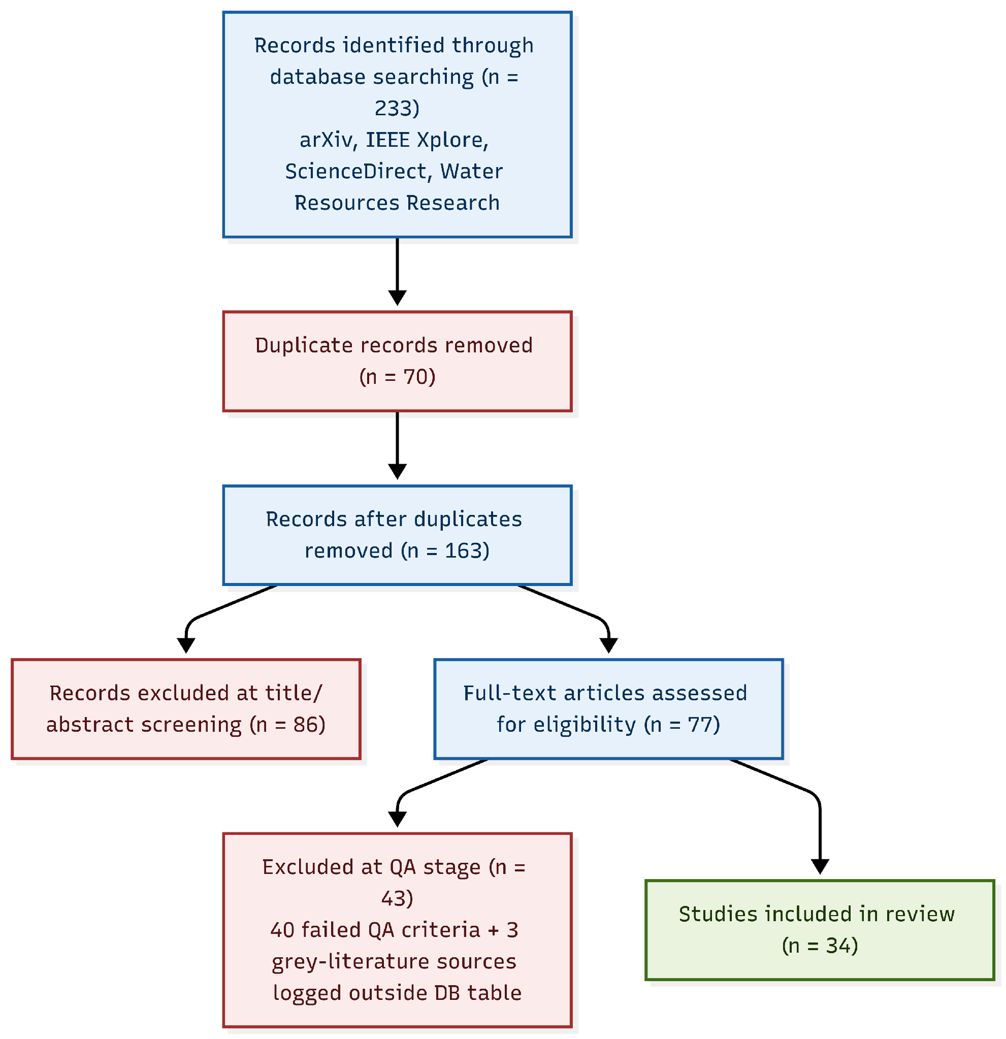
Figure 1: PRISMA flow diagram of the systematic review protocol.
TABLE I: NUMBER OF REVIEWED PAPERS BY DATABASE
Database | Identified | Round 1 Excl./Incl. | Round 2 (QA) Excl./Incl.
arXiv | 115 | 79 / 34 | 19 / 15
IEEE Xplore | 58 | 38 / 20 | 10 / 10
ScienceDirect | 40 | 27 / 12 | 7 / 5
Wiley Online Library | 20 | 12 / 8 | 4 / 4
Other/grey Literature (outside the 233 database records) | --- | --- / 3 | 3 / 0
Database Subtotal | 233 | 156 / 77 | 40 / 37
Overall Total (database + grey literature) | 233 | 156 / 77 | 43 / 34

III. BACKGROUND
3.1 Operational Weather Forecasting and Numerical Weather Information
Operational weather forecasting relies on high-resolution numerical grids, polarimetric radar reflectivity scans, satellite observations, and multivariate time-series datasets [20][6]. While traditional numerical weather prediction (NWP) systems and deep learning surrogates generate highly precise predictions of geopotential heights, wind components, and precipitation fields, these outputs are presented as high-dimensional numerical tables or gridded tensors [23][20]. This creates a critical interpretation challenge for human decision-makers, who must synthesize these dense datasets under strict time constraints to extract causal explanations, identify anomalies, and anticipate secondary or tertiary hazard impacts [23][33][6]. This survey uses five related but distinct terms throughout: forecast generation refers to producing the underlying numerical prediction itself (the domain of NWP and deep-learning surrogates, e.g., [20]); diagnosis refers to identifying the causal or hypothesis-driven explanation behind a forecast or observed pattern (e.g., HVR-Met's hypothesis-verification loop [33]); interpretation refers to translating numerical or gridded output into natural-language meaning; verification refers to checking the correctness, consistency, or physical plausibility of a claim against data or expert rules; and report generation refers to producing the final human-readable narrative. This survey's primary focus is on interpretation, verification, and report generation built atop forecasts and diagnoses produced by upstream systems, rather than on forecast generation itself.
3.2 Large Language Models for Weather Interpretation
Large Language Models (LLMs) are increasingly being explored to translate, interpret, and communicate complex meteorological data into human-readable narratives [11]. However, because LLMs operate on discrete tokens while meteorological time series are inherently continuous, standard models exhibit numerical hallucinations and numerical reasoning limitations [32][2]. Standard subword tokenizers split multidigit values arbitrarily, which impairs an LLM's ability to perform precise spatial-gradient calculations or statistical inequality checks [32][2]. To leverage the pattern recognition of frozen LLMs without resource-intensive fine-tuning, recent work utilizes cross-modality reprogramming to map input time series onto learnable text prototypes that represent temporal properties like 'periodic' or 'seasonal' [2]. This reprogramming paradigm builds on an earlier two-stage fine-tuning strategy that first aligns a frozen LLM to the statistical structure of time series before adapting it to the downstream forecasting task, establishing the patch-based reprogramming template that later weather-specific frameworks extend [1].
3.3 Multimodal and Agentic Weather Systems
To capture the spatiotemporal complexity of atmospheric phenomena, researchers have developed multimodal and agentic weather frameworks [19][6]. Multimodal systems align meteorological grids with discrete text by encoding physical variables into image-like RGB channels, passing them through spatial-temporal visual encoders, and projecting them into LLM word embedding spaces [6]. Furthermore, to prevent context degradation and positional attention bias under dense hourly tables, state-of-the-art systems employ temporal hierarchies (aggregating hourly tables into 6-hour and daily aggregates) and role-based multi-agent orchestration [23][33]. This modular approach delegates tasks (e.g., temporal alignment, scientific script execution, and visual plotting) to specialized, collaborative agent nodes, emulating the professional weather consultation workflow of human experts [23][33].
Because LLMs generate text from learned statistical associations rather than grounded physical laws, they frequently produce statements that appear linguistically plausible but are physically unsupported by the underlying meteorological data [6]. These hallucinations typically manifest in three forms: (1) factual hallucinations, where a narrative claim directly contradicts observational aggregates [32]; (2) causal hallucinations, where the model asserts an invalid cause-effect relationship; and (3) temporal hallucinations, where interpretations conflict across different forecast scales, such as a daily trend disagreeing with hourly local dynamics [25][32]. This definition of hallucination is distinct from several related error types discussed elsewhere in this survey: numerical errors and forecast errors reflect inaccuracy in a computed value or an underlying prediction relative to observed conditions, rather than a narrative claim unsupported by the data; reasoning inconsistency (including Self-Contradictory Reasoning, Section 3.4) describes a mismatch between a model's own intermediate reasoning and its final output, which need not involve any factually unsupported claim; an unsupported inference goes beyond what the available data can justify without necessarily contradicting it, whereas a hallucination as defined here directly contradicts the underlying data; and temporal inconsistency, more broadly, refers to any disagreement between statements issued at different times or scales, of which the temporal hallucination above is the specific case where no valid meteorological explanation reconciles the disagreement. The event-centric and verification techniques underlying several of these hallucination-mitigation strategies are themselves adapted from the broader natural language processing literature. Context-prediction-based coreference resolution and scalable real-time event-extraction pipelines, originally developed for short-text and news-monitoring applications, provide the entity- and event-clustering primitives that meteorological report generators repurpose to link successive weather statements to a single underlying atmospheric event [3][9]. Complementing this, credibility frameworks that atomize claims and re-rank retrieved evidence for effortless fact verification offer a template for the claim-level grounding that hallucination-aware weather-reporting systems must eventually adopt to validate generated narratives against external, verifiable sources [10].
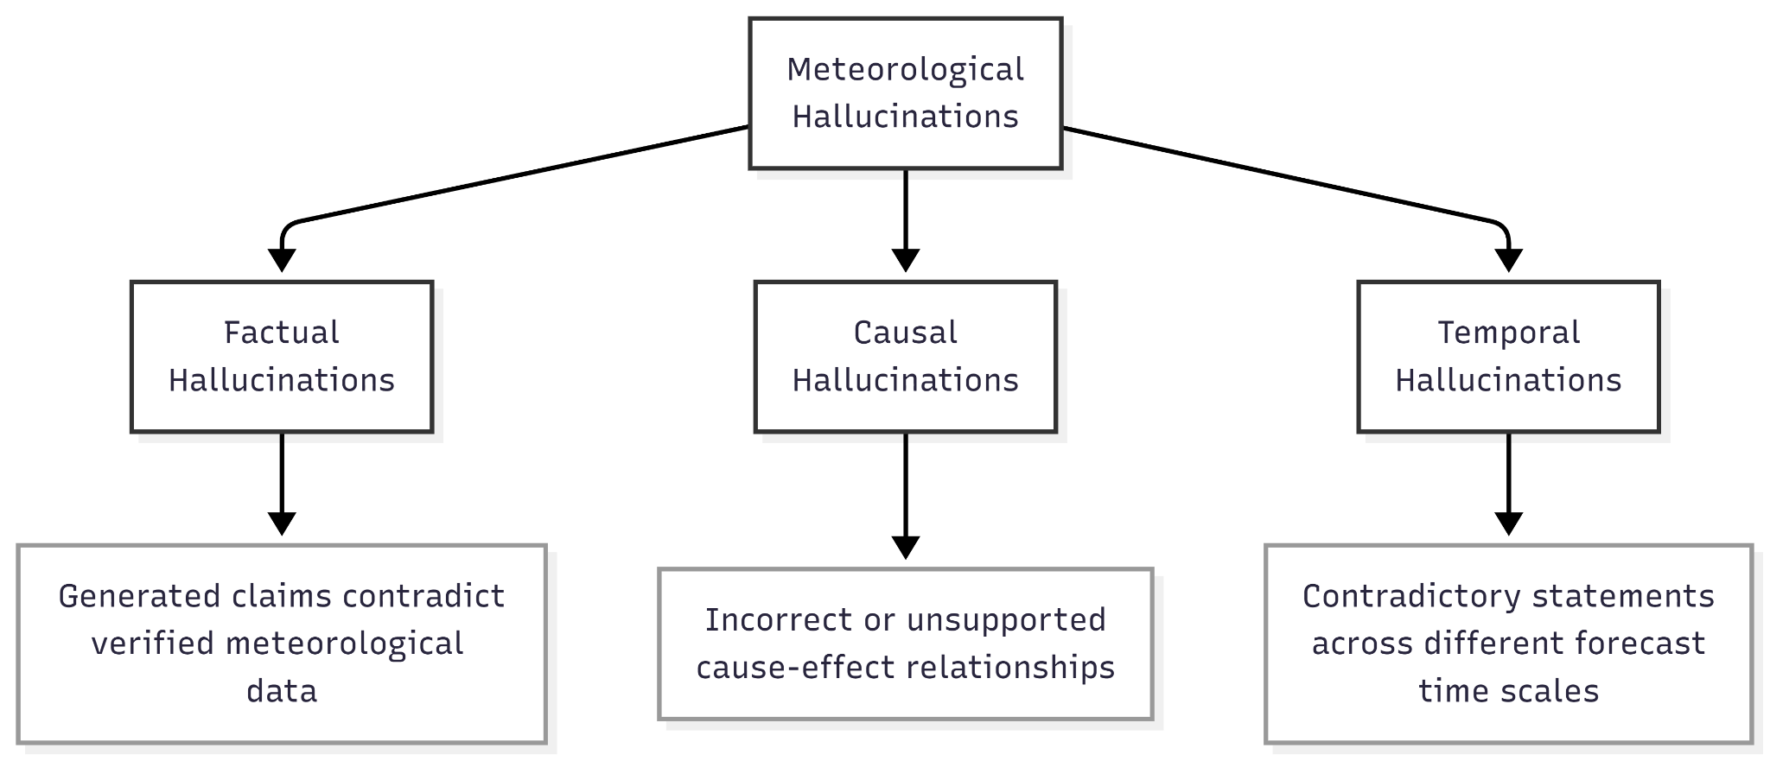
Figure 2: Taxonomy of meteorological hallucination types - factual, causal, and temporal.
3.4 Need for Logical and Physically Consistent Reasoning
In high-stakes, safety-critical domains like severe weather warning, automated reports must maintain strict physical and logical consistency [31][19]. Standard reinforcement learning paradigms can induce Self-Contradictory Reasoning (Self-Contra), wherein a model's generated chain of thought correctly details severe meteorological hazards, but its final multiple-choice selection or warning output directly contradicts its reasoning [31]. Ensuring trustworthy operational decision support therefore demands logical supervised fine-tuning, joint reinforcement learning rewards, and visual-physical verification loops to structurally ground every generated weather keyword in observable data aggregates and proven meteorological principles [23][33][31][8].
The extensive diversity of these representation, orchestration, and logical verification methods highlights the necessity of a structured, multi-tiered taxonomy to organize the reviewed literature.
IV. RESEARCH TAXONOMY
The literature at the intersection of atmospheric science, natural language generation, and cognitive reasoning displays a fragmented landscape, ranging from grid-scale numerical calculations to conversational text summaries [20]. To unify these disparate methodologies, a systematic taxonomy is necessary. This taxonomy organizes the domain into a multi-tiered framework, categorizing research across the core functional dimensions of geoscientific AI systems.
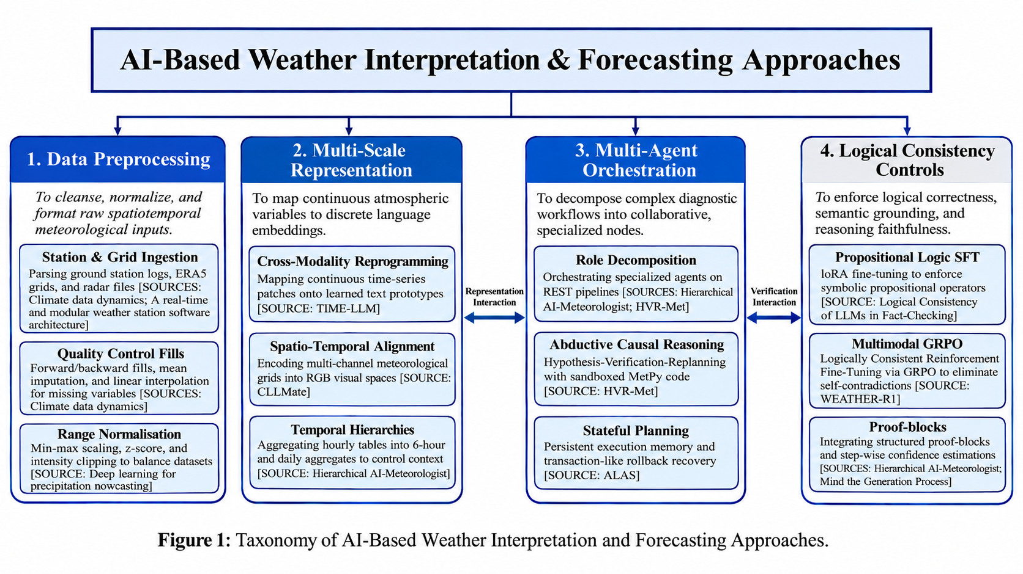
Figure 3: Taxonomy of AI-Based Weather Interpretation and Forecasting Approaches.
Pillar 1: Data Preprocessing
This pillar addresses the ingestion and cleansing of raw, noisy, and heterogeneous meteorological data streams, including gridded reanalysis tensors, polarimetric radar reflectivity scans, satellite imagery, and point-based ground station logs [26][4][7]. It focuses on quality control, structural formatting, and normalization [4][7]. Methodological approaches include forward and backward fills, linear interpolation, and mean imputation to handle missing variables, alongside min-max scaling, z-score normalization, and extreme value clipping to manage severe data imbalances [4][7].
Pillar 2: Multi-Scale Representation
This pillar maps continuous numerical variables onto compatible natural language semantic spaces [2][6]. It resolves the modality gap by transforming high-dimensional atmospheric inputs into tokenized representations that LLMs can digest [2][6]. The main approaches include cross-modality reprogramming, where partitioned time-series patches are mapped onto learned text prototypes using cross-attention mechanisms [2]; spatial-temporal alignment, where gridded reanalysis fields are encoded into multi-channel RGB formats for visual encoders [6]; and temporal hierarchies, which aggregate hourly forecasts into coarser six-hourly and daily records to prevent long-context attention degradation [23].
Pillar 3: Multi-Agent Orchestration
This pillar manages the cognitive execution of the interpretation pipeline by decomposing complex, long-horizon diagnostic tasks into specialized, collaborative agent nodes [23][33]. Rather than relying on a single model, this block orchestrates role-based systems (e.g., Decomposers, Data Specialists, Code Executors, Plotters, Image Checkers, Diagnosticians, and Writers) communicating via structured RESTful APIs [23][33]. The primary methodologies include abductive scientific reasoning, where physical hypotheses are generated and verified against dynamic code executions in sandboxed environments, and stateful planning, which utilizes persistent memory rollback protocols to handle dynamic, real-time schedule disruptions [33][29].
Pillar 4: Logical Consistency Controls
The final pillar enforces truth-value faithfulness, reasoning-to-answer consistency, and physical compliance across the generated narratives [31][8]. It addresses cognitive discrepancies such as self-contradictory reasoning, where models generate correct intermediate chain-of-thought steps but select incorrect final warning options [31]. Main methodologies include supervised fine-tuning (SFT) using Low-Rank Adaptation (LoRA) to constrain internal weights with propositional logic operators [8]; Logically Consistent Reinforcement Fine-Tuning (LoCo-RFT) via Group Relative Policy Optimization (GRPO) utilizing a judge model to penalize reasoning inconsistencies [31]; and fine-grained confidence estimation alongside structured 'proof-blocks' to anchor generated keywords in raw data aggregates [23][16].
These four pillars are highly complementary; they do not simply represent sequential processing steps but rather reflect distinct, co-existing dimensions of advanced geoscientific AI architectures. Together, they provide a complete organizational framework that directly structures the literature review and comparative analysis in the subsequent sections of this survey.
V. LITERATURE REVIEW
Building on the taxonomy above, this section maps the reviewed literature onto a common processing pipeline that most surveyed systems follow in practice (Figure 4), then discusses each stage in detail. Although Section IV established that the four taxonomy pillars are conceptually independent, co-existing dimensions rather than mandatory sequential dependencies, systems that implement multiple pillars typically compose them in the practical order presented below; we use this order here purely for expository clarity, not to reassert a strict sequential dependency between pillars.
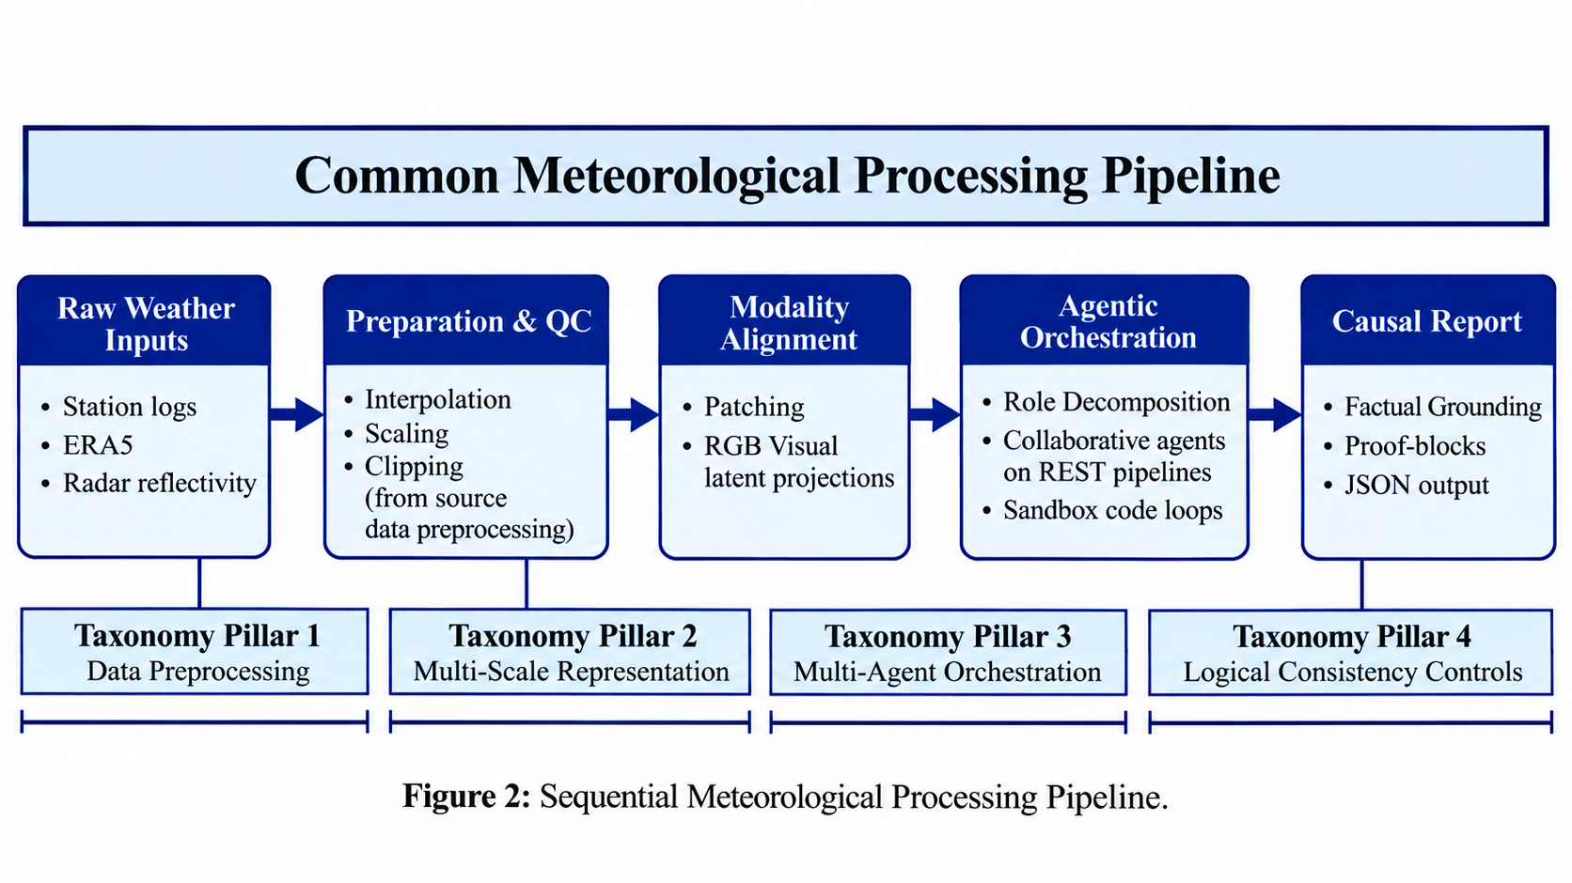
Figure 4: The universal meteorological AI pipeline, illustrating the sequence of processing stages mapped to corresponding taxonomy pillars.
5.1 Data Preprocessing
Data preprocessing serves as the initial gatekeeper in weather AI architectures, transforming noisy, heterogeneous atmospheric sensor outputs into structured arrays [4]. Standard pipelines ingest daily point-based weather station logs, real-time telemetry, or continuous spatiotemporal radar reflectivity scans [26][4][7].
To counter missing telemetry from physical sensor failures, systems deploy forward/backward fills, mean imputation, and linear interpolation [26][7]. Scale imbalances across physical variables are corrected via min-max scaling, z-score normalisation, or logarithmic transforms [4][5]. Crucially, to mitigate overfitting to sparse precipitation matrices, researchers utilize sliding window segmentation and extreme value intensity clipping [4].
5.2 Multi-Scale Representation & Alignment
To interpret weather events, continuous numerical matrices must be mapped onto discrete linguistic spaces [2][6].
Cross-Modality Reprogramming: Frameworks like TIME-LLM normalize inputs using Reversible Instance Normalization (RevIN) and partition them into patches [2]. These patches are projected onto learned text prototypes via multi-head cross-attention, allowing a frozen LLM backbone to reason over temporal features [2]. This is paired with Prompt-as-Prefix (PaP) metadata summarizing trends and lags [2].
Visual-Spatial Projection: Models like CLLMate project gridded reanalysis tensors (e.g., ERA5) as multi-channel RGB rasters, passing them through spatial-temporal visual encoders to project them directly into the word embedding space of language decoders [6]. Building on this multimodal direction, Omni-Weather extends visual-spatial projection to radar data specifically, sharing self-attention layers across a unified radar encoder and a Chain-of-Thought reasoning module so that a single architecture can both interpret raw reflectivity imagery and generate the diagnostic explanation in one pass, though at the cost of substantially higher computational overhead than single-purpose radar models [34].
Temporal Hierarchies: To manage token limits and positional attention decay in medium-range forecasting, frameworks aggregate hourly sequences into coarser 6-hour and daily records, preventing important synoptic features from being 'lost in the middle' [23][29]. A complementary line of work reframes multi-scale temporal reasoning itself as an explicit thinking process: slow-thinking forecasting approaches generate step-by-step reasoning paths over the input sequence, using reinforcement optimization to improve the detection of regime changes and long-range temporal dependencies, albeit with higher training overhead than single-pass forecasters [13]. Outside the LLM-agent literature, hierarchical deep learning models enforce a related form of multi-scale consistency by reconciling forecasts across timescales through temporal hierarchical reconciliation, ensuring that hourly, daily, and coarser predictions remain mutually consistent, although the accuracy gains from this reconciliation are more pronounced at the upper levels of the hierarchy than at fine-grained ones [14].
5.3 Multi-Agent Orchestration & Causal Reasoning
To replace passive prompting and single-turn text generation with active scientific inquiry, the literature has transitioned to collaborative multi-agent orchestration [23][33].
Closed-Loop Reasoning: Systems like HVR-Met decompose weather diagnosis into specialised agents-Decomposers, Data Specialists, Code Executors, Plotters, Image Checkers, and Diagnosticians [33]. The agents retrieve gridded variables, execute calculations in sandboxed MetPy/Xarray environments, verify synoptic plots via Vision-Language Models, and consult a Guideline Library containing expert geoscientific rules [33]. If computed parameters contradict the initial meteorological hypothesis, the system rejects the assumption and triggers a replanning loop [33].
Tool-Augmented Reasoning: Similarly, TimeART deploys a ReAct-style agentic workflow backed by 21 out-of-the-box analytical tools (such as stationarity tests, spike detectors, and change-point classifiers) to ground time-series reasoning without mathematical hallucinations [32].
Stateful Memory: For disruption-aware scheduling under runtime failures, frameworks utilize stateful agent networks with transaction-like rollback memories and Local Reactive Compensation Protocols (LRCP) [29].
5.4 Logical Consistency & Verification Controls
The safety-critical nature of weather forecasting requires strict truth-value grounding and the elimination of self-contradictions [31][8].
Reinforcement Fine-Tuning: Systems frequently experience Self-Contradictory Reasoning (Self-Contra), where their intermediate reasoning traces outline severe storm indicators but their final choice outputs contradict this analysis [31]. WEATHER-R1 resolves this by employing joint format, accuracy, and logical consistency rewards (R_LoCo) evaluated by an independent judge model during Group Relative Policy Optimization (GRPO) [31].
Supervised Logical Alignment: Researchers also apply Supervised Fine-Tuning (SFT) using Low-Rank Adaptation (LoRA) to constrain model weights with symbolic propositional logic rules (conjunction, disjunction, negation), significantly boosting logical robustness [8].
Structured Semantic Grounding: To enforce narrative verifiability, the Towards Trustworthy AI Meteorology introduces evidential proof-blocks and controlled vocabularies, ensuring that every generated meteorological keyword is mathematically grounded in observed tabular aggregates [23]. Similarly, models are fine-tuned with Backward Confidence Integration (BCI) to estimate step-wise confidence levels during autoregressive generation, pruning hallucinated assertions [16]. Table II summarizes a representative, non-exhaustive selection of 18 of the 34 primary studies, chosen to illustrate the methodological range across all four taxonomy pillars. Entries marked (Adjacent) are drawn from domains outside weather forecasting itself (e.g., general fact-checking, disruption-aware scheduling, hydrological forecasting) that were included per the eligibility criteria in Section 2.2 for their methodologically transferable techniques, rather than for direct weather-forecasting contributions. Because the reported metrics (e.g., RMSE, MSE, accuracy, expert-rubric scores, semantic-integrity rates) were measured on different datasets, tasks, and scales, they are not directly comparable across rows and should not be read as a cross-study performance ranking
TABLE II: COMPARATIVE SUMMARY OF REPRESENTATIVE REVIEWED STUDIES
Paper | Year | Method / Architecture | Main Task | Key Finding / Limitation
A real-time and modular weather station software architecture based on microservices | 2025 | Microservice REST API, Docker, Random Forest, ANNs | Ingesting real-time telemetry | Scales telemetry quality control / Lacks automated reasoning or text generation
Real-Time Data Integration and Weather Reporting Automation with Cloud Computing-based Interactive Spatial Dashboard for Extreme Weather Risk Analytics in Indonesia | 2025 | Cloud-based REST API, Flask backend | Automated weather reporting | Integrates telemetry in <1 min / Lacks native physical constraints or causal reasoning
Weather On-Demand (WOD) forecasting framework | 2025 | Microservice REST API with variational data assimilation | Operational forecast setup | Streamlines data assimilation into pipelines / Closed-source framework
Climate data dynamics: A high-volume real world structured weather dataset | 2024 | Python cleaning, fills, mean imputation | Cleaning raw station CSV files | Generates highly structured daily datasets / Limited to point-based daily parameters
Deep learning for precipitation nowcasting: A survey from the perspective of time series forecasting | 2024 | Sliding window segmentation, clipping | Systematizing nowcasting step | Standardizes preprocessing to mitigate noise / Strictly focused on precipitation nowcasting
Exploring large language models for climate forecasting | 2025 | Conversational climate forecasting prompting | Translating climate parameters | Showcases feasibility of climate projections / Lacks multi-scale temporal reconciliation
Hierarchical Deep Learning for Consistent Multi-Timescale Hydrological Forecasting | 2025 | LSTMs + Temporal Hierarchical Reconciliation | Multiscale streamflow forecasting (Adjacent) | Ensures multi-timescale physical consistency / Confined strictly to numerical vectors
OneForecast: A Universal Framework for Global and Regional Weather Forecasting | 2025 | Region Refined Graph Encoder, GNN | Global & Regional forecasting | Reduces geopotential height RMSE significantly / High spatial smoothing under long rollout
CLLMate: A Multimodal LLM for Weather and Climate Events Forecasting | 2024 | RGB projection, visual encoder, Llama3-8B | Directly forecasting events from grids | BERTScore of 73.56 by aligning grids with text / Geographically biased toward China
TIME-LLM: Time Series Forecasting by Reprogramming Large Language Models | 2024 | RevIN, linear patch embedder, cross-attention | Reprogramming frozen foundation backbones | Outperforms specialized models on MSE; 71.2% fewer parameters than QLoRA PEFT fine-tuning / High inference latency
Hierarchical AI-Meteorologist: LLM-Agent System for Multi-Scale and Explainable Weather Forecast Reporting | 2026 | Meteorologist, Writer Agents over REST | Forecast narrative generation | Aggregations prevent token-bias & attention decay / Cannot perform active tabular calculations
HVR-Met: A Hypothesis-Verification-Replanning Agentic System for Extreme Weather Diagnosis | 2026 | Decomposer, Specialist, Code Executor, Plotter, VLM | Closed-loop extreme diagnosis | Achieves report score of 3.94/5 via abductive loops / High operational latency and cost
ALAS: A Stateful Multi-LLM Agent Framework for Disruption-Aware Planning | 2025 | Specialized roles, persistent memory, LRCP | Disruption-aware scheduling (Adjacent) | Tracks transitions and rollbacks under failures / Evaluated only in OR-JSSP simulations
TimeART: Towards Agentic Time Series Reasoning via Tool-Augmentation | 2025 | TSRM agent, ReAct, 21 analytical tools | Agentic time-series Q&A | Mitigates numerical hallucinations by tool execution / Sensitive to context length
WEATHER-R1: Logically Consistent Reinforcement Fine-Tuning for Multimodal Reasoning in Meteorology | 2026 | Logically-Consistent RFT (LoCo-RFT) via GRPO | Multimodal reasoning in meteorology | Suppresses Self-Contradictory reasoning to 1.82% / Dependent on structured formats
Logical Consistency of Large Language Models in Fact-Checking | 2025 | Supervised Fine-Tuning (SFT) with QLoRA | Negation and conjunction fact-checking (Adjacent) | SFT on primitive rules generalizes to complex rules / Restrained to binary yes/no classifications
Mind the Generation Process: Fine-Grained Confidence Estimation During LLM Generation | 2025 | Monte Carlo sampling, clustering, BCI SFT | Estimating step-wise confidence (Adjacent) | Reduces ECE and improves selective accuracy / High computational cost during data preparation
Yours Truly: A Credibility Framework for Effortless LLM-Powered Fact Checking | 2024 | Claim Atomizer, Fact Searcher, Reranker, RAG | Compound claim verification (Adjacent) | F1 score of 94% on TRUTHSEEKER 2023 / Text-only; vulnerable to multimodal deepfakes

VI. COMPARATIVE ANALYSIS
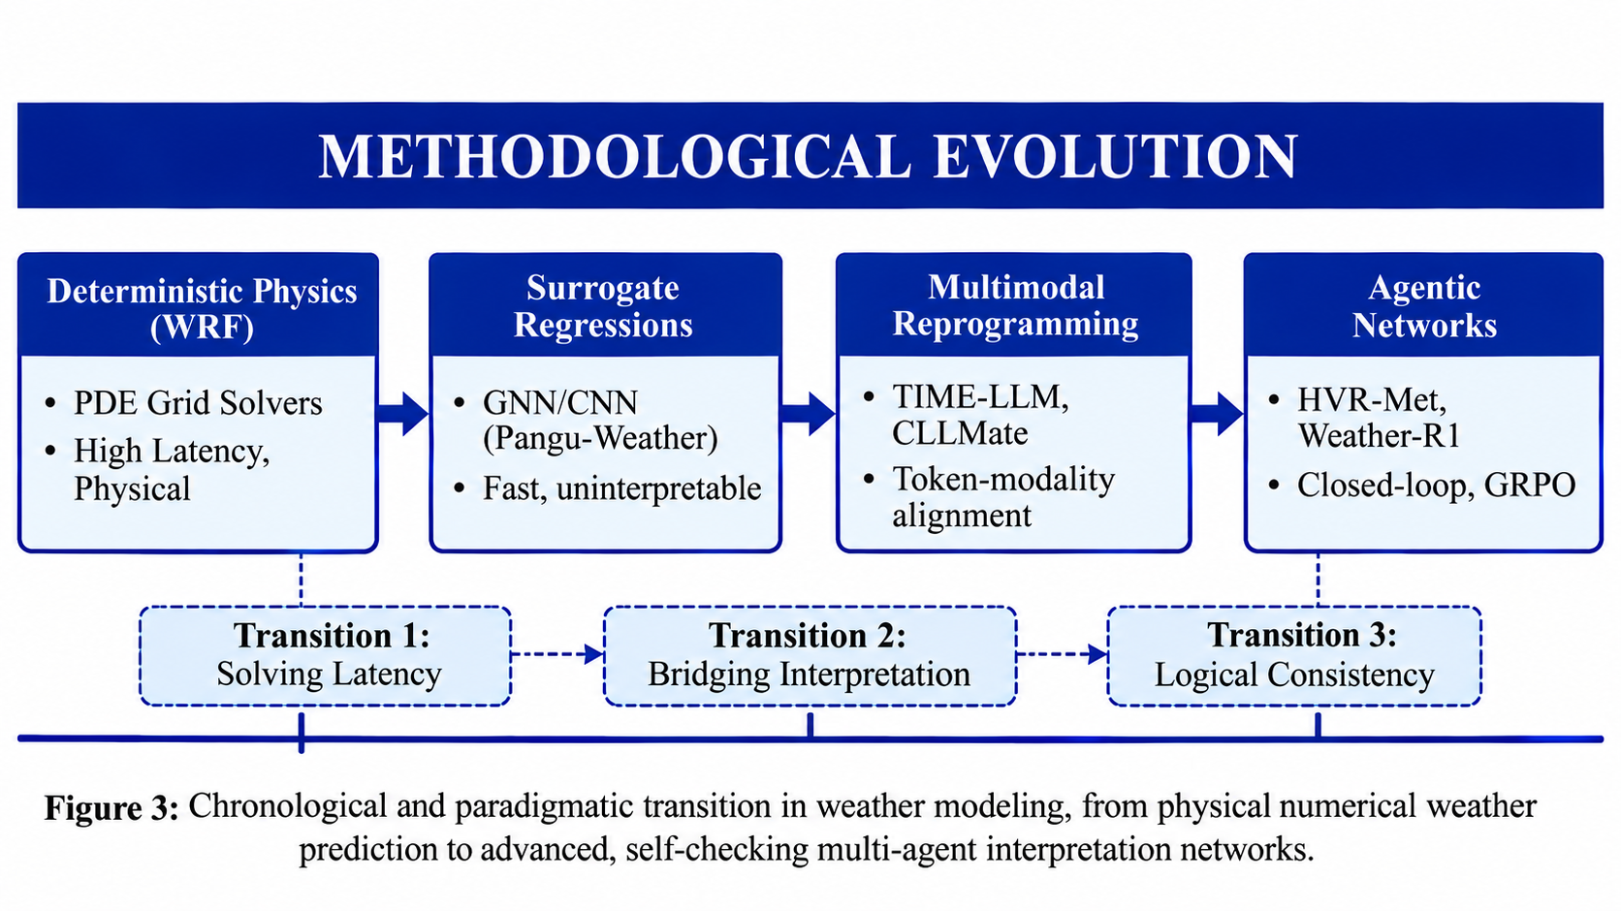
Figure 5: Chronological and paradigmatic transition in weather modeling, from physical numerical weather prediction to advanced, self-checking multi-agent interpretation networks.
6.1 Continuous Time-Series Reprogramming vs. Structured Tool-Augmentation
A primary methodological division exists between systems that reprogram the latent space of frozen language models and those that augment models with external execution tools [32][2].
Representation and Modality Alignment: The reprogramming paradigm, exemplified by TIME-LLM, completely bypasses standard subword tokenization [2]. It utilizes Reversible Instance Normalization (RevIN) and a linear patch embedder to segment continuous time-series into patches, which are then mapped to learned text prototypes using a multi-head cross-attention layer [2]. This approach addresses the numerical reasoning limitation caused by tokenizing continuous numbers directly [32][2]. In contrast, the tool-augmented paradigm, represented by TimeART, retains the textual tokenization of the base LLM but offsets numerical reasoning limitations by interfacing the model with 21 out-of-the-box mathematical and statistical APIs [32].
Reasoning and Orchestration: TIME-LLM relies on a passive Prompt-as-Prefix (PaP) containing dataset context, task instructions, and pre-calculated statistics to guide the frozen backbone's internal attention mechanism [2]. Conversely, TimeART uses an active ReAct-style reasoning loop where the model iteratively generates thoughts, selects and executes tools, observes the outputs, and refines its final answer [32].
Scalability, Robustness, and Latency: TIME-LLM is highly parameter-efficient during training, requiring optimization of less than 1% of the backbone's total parameters [2]. However, it suffers from high computational latency during inference, as every forward pass must traverse the massive frozen LLM layers [2]. TimeART avoids heavy parameter updates but is bounded by the precision and latency of its external tools [32].
6.2 Multimodal Raster-to-Text Alignment vs. Multi-Agent Orchestration
Another critical comparison arises between multimodal vision-to-language projection models and collaborative, role-based multi-agent reasoning networks [33][6].
Data Inputs and Mapping: Multimodal systems like CLLMate ingest 2D gridded reanalysis fields (such as ERA5) directly by encoding physical parameters (temperature, wind, precipitation) as multi-channel RGB rasters [6]. These rasters are passed through spatial-temporal visual encoders and projected into the LLM's word embedding space via a multi-layer perceptron (MLP) [6]. Multi-agent systems, such as HVR-Met and the Hierarchical AI-Meteorologist, operate primarily on serialized tabular data [23][33].
Verification and Causal Grounding: Multi-agent orchestration frameworks offer superior, traceable causal grounding [23][33]. In HVR-Met, a Decomposer Agent coordinates with a Data Specialist to retrieve weather grids and a Code Executor to run sandboxed Python scripts using MetPy and Xarray [33]. A Plotter and an Image Checker visually inspect the output, which a Diagnostician validates against an expert Guideline Library built from 584 extreme weather publications [33]. If the calculated indices contradict the initial hypothesis, the system formally rejects the assumption and triggers a replanning cycle [33]. This closed-loop abductive reasoning is absent in single-model vision-language systems like CLLMate, which generate descriptions in a single auto-regressive pass, leaving them vulnerable to hallucinations [33][6].
6.3 Comparative Trade-offs and Synthesis Conclusions
These paradigms present clear operational trade-offs. Reprogrammed and multimodal projection models (TIME-LLM, CLLMate) offer tight integration of physical data into latent spaces, providing strong zero-shot and few-shot generalization across spatial-temporal grids [2][6]. However, they function as 'black boxes' lacking explicit, step-wise logical verifiability [33][6].
In contrast, modular multi-agent architectures (HVR-Met, Hierarchical AI-Meteorologist, ALAS) serve as 'white-box' platforms that enforce physical and structural consistency through explicit proof-blocks, controlled keyword vocabularies, and persistent transaction-style execution memory [23][33][29]. The reviewed literature suggests that a promising direction may lie in a hybrid approach: leveraging pre-trained continuous feature models as specialized 'tools' coordinated by a high-level, logically verified agentic orchestrator [33][32][30].
VII. QUANTITATIVE ANALYSIS & BENCHMARKS
To establish a rigorous empirical baseline, we present a systematic quantitative performance synthesis of verified results reported across the reviewed literature. Because these frameworks were evaluated on divergent datasets, tasks, and modalities, we group our quantitative analysis into four distinct, non-combinable benchmark settings.
7.1 Global and Regional NWP Surrogates
On the WeatherBench2 benchmark (utilizing ERA5 data spanning 1959–2020), OneForecast was evaluated against state-of-the-art deep learning surrogates, including Pangu-Weather, GraphCast, and Fuxi [20]. It demonstrates lower geopotential height (Z500) root mean square error (RMSE) than the compared baselines across both short-range and extended ten-day forecasting horizons on this benchmark [20]. Additionally, in real-world tropical cyclone track tracking, OneForecast reduces track position errors to 157 km, outperforming GraphCast's 197 km and Pangu's 231 km [20].
7.2 Time-Series Reprogramming (TIME-LLM)
Evaluated on the ETT datasets (input length T=512, averaged across prediction horizons H ∈ {96, 192, 336, 720}), TIME-LLM (leveraging Llama-7B as the default frozen backbone) reports lower error than the compared specialized time-series architectures and fine-tuned language models under the evaluated ETT settings [2]. Under standard configurations, TIME-LLM achieves an ETTh1 MSE of 0.408 and an ETTm1 MSE of 0.329, representing an average performance gain of over 12% compared to GPT4TS (which requires parameter fine-tuning) [2].
In data-scarcity scenarios (using only 5% of available training steps), TIME-LLM maintains its advantage, realizing a 20% MSE reduction over TimesNet and PatchTST [2]. Furthermore, compared to Parameter-Efficient Fine-Tuning (PEFT) using QLoRA, model reprogramming yields a 71.2% reduction in trainable parameters, a 23.1% reduction in GPU memory overhead, and a 25.3% increase in training speed [2].
7.3 Extreme Weather Diagnosis (HVR-Met)
In end-to-end extreme weather diagnosis across 100 severe historical events, the HVR-Met multi-agent framework was evaluated using a professional meteorological scoring rubric (0–5 scale, verified by senior forecasters) [33]. GPT-5 coordinated via HVR-Met achieves an exceptional Final Report score of 3.94, outperforming DeepSeek-R1's 2.97 and Qwen3-Coder's 2.33 [33].
An ablation study reveals that omitting the Guideline Library causes the Hypothesis score to drop precipitously from 4.70 to 1.27, and the Final Report score to collapse to 0.40 [33]. Furthermore, HVR-Met achieves a 71.86% accuracy rate in multi-step composite index calculations (Relative Error < 0.05) and a 79.52% semantic integrity match rate in automated plotting tasks [33].
7.4 Logical Consistency and Alignment
The logical consistency of pre-trained and fine-tuned models was evaluated using propositional logic benchmarks (FreebaseLFC, NELLLFC, WikiLFC) [8] and reinforcement-tuned datasets (ScienceQA, WeatherQA) [31].
Propositional SFT: On NELLLFC conjunction tasks (p ∧ q), supervised fine-tuning via QLoRA improves Llama2-13B accuracy from 0.38 to 0.89, and its logical consistency from 0.69 to 0.88 [8].
Reinforcement Learning (WEATHER-R1): Under out-of-distribution (OOD) testing on ScienceQA, Weather-R1-7B achieves a multimodal reasoning accuracy of 86.46%, outperforming standard SFT (78.22%) and the baseline Qwen2.5-VL-7B (81.48%) [31]. Most importantly, on WeatherQA, Weather-R1-7B reduces Self-Contradictory Reasoning (Self-Contra) from 33.23% for RFT-7B to 1.82%; on the OOD ScienceQA benchmark, it reduces Self-Contra from 20.02% to 2.47% [31].
VIII. CHALLENGES AND RESEARCH GAPS
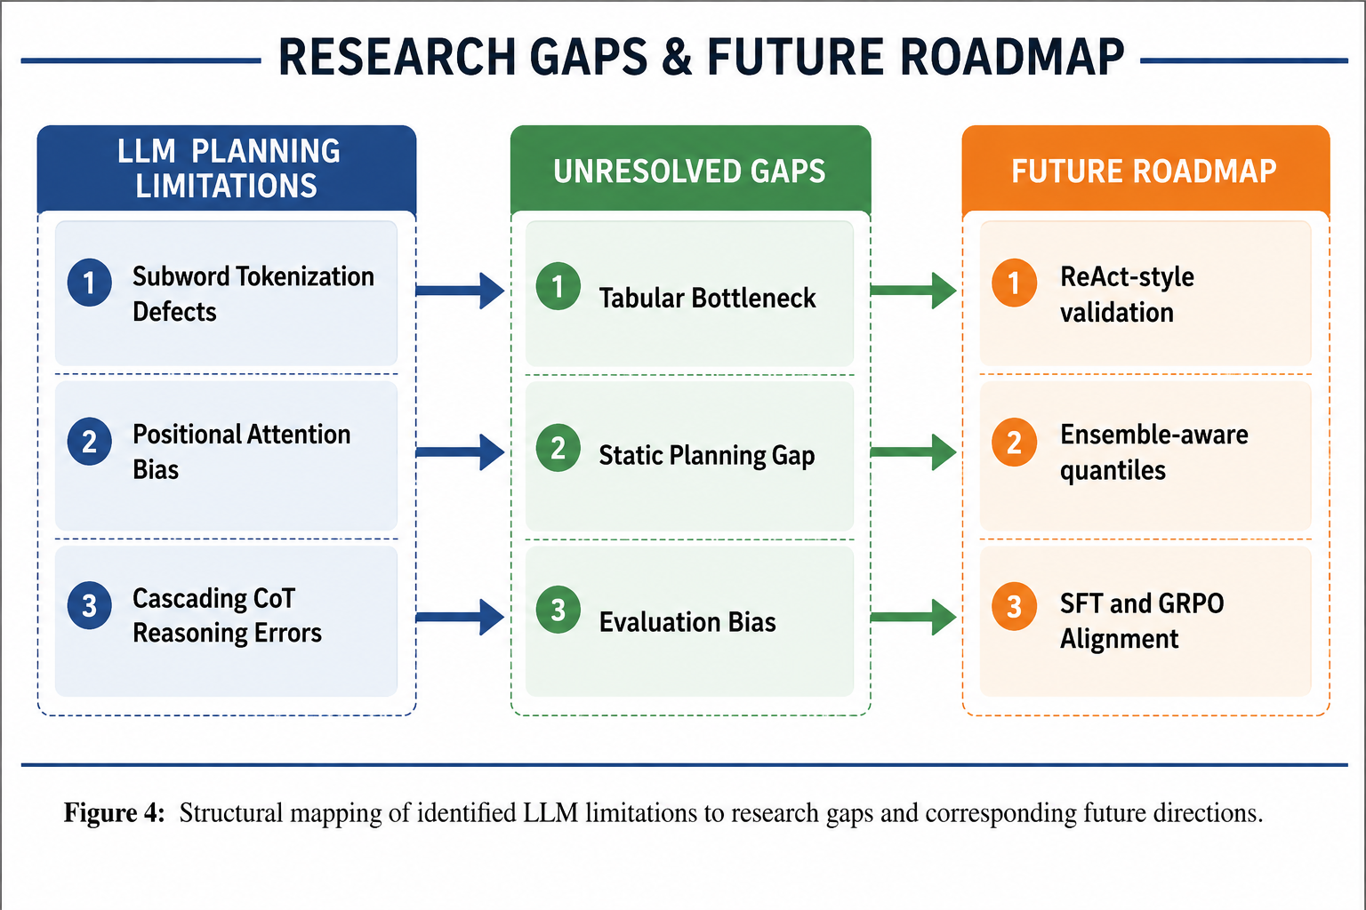
Figure 6: Structural mapping of identified LLM limitations to research gaps and corresponding future directions.
8.1 Cross-Cutting Cognitive and Structural Challenges
Challenge 1 - The Continuous-to-Discrete Modality Gap: The fundamental mismatch between continuous geoscientific variables and the discrete subword tokenizers of Large Language Models represents a persistent bottleneck [32][2]. Standard tokenizers partition multi-digit meteorological values arbitrarily, destroying physical scaling and local temporal context [32][2]. While TIME-LLM bypasses this through linear patching and learned text prototype alignment, this mapping is computationally expensive and caps performance to the representational richness of a fixed vocabulary [2]. Tool-augmented models like TimeART delegate calculations to external APIs, but this introduces severe inference latency and prevents the language model from learning native mathematical structures, resulting in a representational reasoning gap [32].
Challenge 2 - Context Sizing, Attention Decay, and the 'Lost-in-the-Middle' Phenomenon: As meteorological forecasting lead times scale from short-range (1–2 days) to medium-range (5–10 days), the volume of tabular hourly variables grows exponentially [23][29]. Ingesting these dense tables directly exposes standard LLMs to severe attention dilution and positional confusion, where critical, localized extreme weather anomalies located in the middle of a long prompt are completely ignored [23][29]. While the Towards Trustworthy AI Meteorology mitigates this by dynamically aggregating hourly data into coarser 6-hour and daily records, this filtering process inevitably removes highly local, sub-hourly physical details (such as convective microburst wind gusts or rapid frontal wind shifts), creating a direct conflict between context-window limits and meteorological precision [23].
Challenge 3 - Causal Faithfulness, Error Cascades, and Self-Contradictory Reasoning: Multi-step, chain-of-thought (CoT) reasoning is highly vulnerable to cascading error propagation [31][29]. In complex diagnostics, an early numerical error in calculating geostrophic wind components or moisture convergence scales exponentially down the reasoning trace, resulting in physically absurd warnings [33]. Most critically, models suffer from Self-Contradictory Reasoning (Self-Contra), where their intermediate reasoning traces correctly diagnose severe storm indices but their final warning selection is completely incorrect [31]. Current RL paradigms exacerbate this behavior because they reward final answer correctness without evaluating the logical consistency of the thinking steps [31].
Challenge 4 - Geographical and Climatological Selection Bias: Multimodal alignment models are frequently trained and validated on geographically constrained datasets [17][6]. For example, CLLMate's event vocabulary is extracted from news sources localized primarily to East Asia [6], while Multi-Weather DomainShifter is evaluated on German urban architectures [17]. These localized biases represent a severe generalizability bottleneck: a model aligned with East Asian monsoonal weather semantics fails to interpret the dry, severe convective profiles of the US Great Plains or the high-altitude dynamics of the Andes, requiring extensive cross-region and out-of-distribution (OOD) validation [31][6].This evaluation gap is compounded by the absence of standardized agentic environments tailored to meteorological reasoning. General-purpose gym-style simulators that provide asynchronous, vectorized environment-agent interfaces for reinforcement learning have begun to formalize how agentic LLMs are trained and benchmarked, while protocol-driven benchmarks connecting agents to real, tool-rich servers evaluate multi-hop planning and cross-tool coordination under realistic task complexity [18][28]. Weather science has only recently gained a comparable resource: an agentic framework that equips LLMs with a code-execution environment for querying gridded forecasts, geocoding natural-language locations, and running climate simulations, paired with a benchmark spanning basic lookups through counterfactual reasoning [21]. The absence of a meteorology-specific counterpart to these general agentic gyms and tool-benchmarks is itself part of the Evaluation Standardization Gap identified in Table II.
TABLE III: STRUCTURED MAPPING OF RECURRING LLM LIMITS TO OUTSTANDING GEOSCIENTIFIC RESEARCH GAPS AND PROPOSED SOLUTIONS
LLM Challenge | Outstanding Gap | Pillar Affected | Proposed Resolution | Crucial Benefits
Numerical Hallucination & Tokenization Defects | Tabular Reasoning Bottleneck: Reporting models lack active, programmatic validation of weather tables | Pillar 3: Orchestration & Causal Reasoning | Deploying ReAct-Style Tooling: Integrate active validator agents triggering Python scripts | Replaces text guessing with code-grounded scientific auditing
Positional Attention Bias & Context Degradation | Static Planning Gap: Inability of systems to dynamically update forecasts under streaming data | Pillar 3: Multi-Agent Orchestration | Stateful Planning & Persistent Memory: Incorporate local reactive compensation (LRCP) | Enables real-time correction of bulletins without global replanning
CoT Error Cascade Propagation | Evaluation Standardization Gap: Field lacks open-source benchmarks to evaluate physical coherence | Pillar 4: Logical Consistency & Verification | Logically Consistent RFT: Optimize weights via GRPO with logical correctness rewards | Aligns intermediate reasoning traces directly with final selected outputs
Deterministic Presentation Bias | Climatological & Ensemble Gap: None of the reviewed systems (Section V) reason over ensemble or probabilistic forecast distributions; all report single-point deterministic outputs [20][2] | Pillar 4: Logical Consistency & Verification | Ensemble-Aware Contexts: Inject distribution quantiles (p10–p90 spreads) into prefix prompts | Synthesizes risk-calibrated warnings and probability-tagged keywords

IX. CONCLUSION
This survey has systematically reviewed the state-of-the-art in automated weather forecasting, representation, and interpretation, focusing on the emerging paradigm of modular Large Language Model (LLM) agent systems [23][31][20][2]. While purely data-driven deep learning surrogates have accelerated global prediction speeds [20], the operational requirement to translate continuous numerical grids into explainable, trustworthy narratives demands a cognitive paradigm shift [23].
To guide the community, we have established a formal taxonomy organized around four structural pillars: data preprocessing, multi-scale representation, multi-agent orchestration, and logical consistency controls [23]. Our synthesis of the literature demonstrates that continuous-to-discrete representation alignment (via time-series reprogramming and spatial visual embeddings) successfully overcomes the numerical tokenization bottlenecks of standard language models [2][6]. Furthermore, modular multi-agent orchestration networks that leverage closed-loop abductive planning, sandboxed Python execution, and persistent execution memories provide traceable diagnostic reasoning modeled on professional forecasting workflows [33][29].
Finally, we highlighted how logical supervised fine-tuning and reinforcement learning from joint consistency rewards (such as GRPO) structurally suppress self-contradictory reasoning, supporting progress toward operational safety [31][8]. By outlining a three-pronged roadmap-integrating active ReAct-style validation, ensemble-aware probabilistic context, and logic-aligned GRPO-this survey provides a systematic foundation for transitioning automated weather interpreters from experimental research prototypes into robust, self-checking operational pipelines that bridge the gap between geoscientific numbers and actionable narratives [23][33][31].
X. REFERENCES
[1] C. Chang, W.-C. Peng, and T.-F. Chen, "LLM4TS: Two-Stage Fine-Tuning for Time-Series Forecasting with Pre-Trained LLMs," arXiv preprint arXiv:2308.08469, Aug. 2023, [Online]. Available: https://arxiv.org/abs/2308.08469
[2] M. Jin et al., "TIME-LLM: Time Series Forecasting by Reprogramming Large Language Models," arXiv preprint arXiv:2310.01728, Oct. 2023, [Online]. Available: https://arxiv.org/abs/2310.01728
[3] X. Yong, C. Zeng, L. Dai, W. Liu, and S. Cai, "Short Text Event Coreference Resolution Based on Context Prediction," Applied Sciences, vol. 14, no. 527, Jan. 2024, [Online]. Available: https://www.mdpi.com/2076-3417/14/2/527
[4] S. An et al., "Deep Learning for Precipitation Nowcasting: A Survey from the Perspective of Time Series Forecasting," arXiv preprint arXiv:2406.04867, Jun. 2024, [Online]. Available: https://arxiv.org/abs/2406.04867
[5] B. Li and Y. Qian, "Weather Prediction Using CNN-LSTM for Time Series Analysis: A Case Study on Delhi Temperature Data," arXiv preprint arXiv:2409.09414, Sep. 2024, [Online]. Available: https://arxiv.org/abs/2409.09414
[6] H. Li et al., "CLLMate: A Multimodal LLM for Weather and Climate Events Forecasting," arXiv preprint arXiv:2409.19058, Sep. 2024, [Online]. Available: https://arxiv.org/abs/2409.19058
[7] M. Zubair et al., "Climate data dynamics: A high-volume real world structured weather dataset," Data in Brief, vol. 57, Nov. 2024, [Online]. Available: https://www.sciencedirect.com/science/article/pii/S2352340924011181
[8] B. Ghosh et al., "Logical Consistency of Large Language Models in Fact-Checking," arXiv preprint arXiv:2412.16100, Dec. 2024, [Online]. Available: https://arxiv.org/abs/2412.16100
[9] M.-C. Avornicului et al., "Designing a Prototype Platform for Real-Time Event Extraction: A Scalable Natural Language Processing and Data Mining Approach," Electronics, vol. 13, no. 4938, Dec. 14, 2024, [Online]. Available: https://www.mdpi.com/2079-9292/13/24/4938
[10] V. Krishnamurthy and V. Balaji, "Yours Truly: A Credibility Framework for Effortless LLM-Powered Fact Checking," IEEE Access, vol. 12, Dec. 19, 2024, [Online]. Available: https://ieeexplore.ieee.org/document/10807167
[11] Y. Wang and H. A. Karimi, "Exploring Large Language Models for Climate Forecasting," Applied Computing and Intelligence, vol. 5, no. 1, pp. 1-13, Jan. 6, 2025, [Online]. Available: https://www.aimspress.com/article/doi/10.3934/aci.2025001
[12] D. Gosmar et al., "Prompt Injection Detection and Mitigation via AI Multi-Agent NLP Frameworks," arXiv preprint arXiv:2503.11517, Mar. 17, 2025, [Online]. Available: https://arxiv.org/abs/2503.11517
[13] Y. Luo et al., "Time Series Forecasting as Reasoning: A Slow-Thinking Approach," arXiv preprint arXiv:2506.10630, June 2025, [Online]. Available: https://arxiv.org/abs/2506.10630
[14] M. S. Jahangir and J. Quilty, "Hierarchical Deep Learning for Consistent Multi‐Timescale Hydrological Forecasting," Water Resources Research, vol. 61, June 17, 2025, [Online]. Available: https://agupubs.onlinelibrary.wiley.com/doi/10.1029/2024WR038105
[15] K. B. Arifani et al., "Real-Time Data Integration and Weather Reporting Automation with Cloud Computing-based Interactive Spatial Dashboard for Extreme Weather Risk Analytics in Indonesia," Journal of Computer Networks, Architecture and High Performance Computing, vol. 7, no. 3, July 21, 2025, [Online]. Available: https://jurnal.itscience.org/index.php/CNAPC/article/view/6298
[16] J. Han et al., "FineCE: Fine-Grained Confidence Estimation During LLM Generation," arXiv preprint arXiv:2508.12040, Aug. 16, 2025, [Online]. Available: https://arxiv.org/abs/2508.12040
[17] Yubo Wang et al., "Multi-Weather DomainShifter: A Comprehensive Multi-Weather Transfer LLM Agent for Handling Domain Shift in Aerial Image Processing," PubMed, Sep. 13, 2025, [Online]. Available: https://pubmed.ncbi.nlm.nih.gov/41295112/
[18] Zichen Liu et al., "GEM: A Gym for Agentic LLMs," arXiv preprint arXiv:2510.01051, Oct. 1, 2025, [Online]. Available: https://arxiv.org/abs/2510.01051
[19] Michael Chen et al., "AgentCaster: Reasoning-Guided Tornado Forecasting," arXiv preprint arXiv:2510.03349, Oct. 2, 2025, [Online]. Available: https://arxiv.org/abs/2510.03349
[20] Yuan Gao et al., "OneForecast: A Universal Framework for Global and Regional Weather Forecasting," arXiv preprint arXiv:2502.00338, Oct. 6, 2025, [Online]. Available: https://arxiv.org/abs/2502.00338
[21] S. Varambally et al., "Zephyrus: An Agentic Framework for Weather Science," Oct. 2025, [Online]. Available: https://arxiv.org/abs/2510.04017
[22] D. Pantiukhin et al., "Accelerating Earth Science Discovery via Multi-Agent LLM Systems," Frontiers in Artificial Intelligence, vol. 8, Nov. 11, 2025, [Online]. Available: https://www.frontiersin.org/journals/artificial-intelligence/articles/10.3389/frai.2025.1674927/full
[23] D. Sukhorukov et al., "Hierarchical AI-Meteorologist: LLM-Agent System for Multi-Scale and Explainable Weather Forecast Reporting," arXiv preprint arXiv:2511.23387, Nov. 22, 2025, [Online]. Available: https://arxiv.org/abs/2511.23387
[24] M. S. Pavithran et al., "Multi-Scale Weather Forecasting Using Deep Learning Architectures with Chennai Climate Data," IEEE Access, vol. 13, pp. 207303-207315, 2025, [Online]. Available: https://doi.org/10.1109/ACCESS.2025.3640667
[25] Tingjia Miao et al., "PhysMaster: Building an Autonomous AI Physicist for Theoretical and Computational Physics Research," arXiv preprint arXiv:2512.19799, Dec. 22, 2025, [Online]. Available: https://arxiv.org/abs/2512.19799
[26] J. Bonilla et al., "A real-time and modular weather station software architecture based on microservices," Environmental Modelling and Software, vol. 186, 2025, [Online]. Available: https://www.sciencedirect.com/science/article/pii/S1364815225000210
[27] Ó. Rögnvaldsson et al., "The Weather On-Demand Framework," Atmosphere, vol. 16, no. 91, 2025, [Online]. Available: https://www.mdpi.com/2073-4433/16/1/91
[28] Zhenting Wang et al., "MCP-Bench: Benchmarking Tool-Using LLM Agents with Complex Real-World Tasks via MCP Servers," arXiv preprint arXiv:2508.20453, 2025, [Online]. Available: https://arxiv.org/abs/2508.20453
[29] E. Y. Chang and L. Geng, "ALAS: A Stateful Multi-LLM Agent Framework for Disruption-Aware Planning," arXiv preprint arXiv:2505.12501, 2025, [Online]. Available: https://arxiv.org/abs/2505.12501
[30] G. Wijngaard, E. Formisano, M. Dumontier, and J. Jitsev, "AudioToolAgent: An Agentic Framework for Audio-Language Models," arXiv preprint arXiv:2510.02995, 2025, [Online]. Available: https://arxiv.org/abs/2510.02995
[31] K. Wu et al., "WEATHER-R1: Logically Consistent Reinforcement Fine-Tuning for Multimodal Reasoning in Meteorology," in Proc. IEEE Int. Conf. Acoustics, Speech and Signal Processing (ICASSP), 2026, [Online]. Available: https://arxiv.org/abs/2601.14044
[32] Xingjian Wu et al., "TimeART: Towards Agentic Time Series Reasoning via Tool-Augmentation," arXiv preprint arXiv:2601.13653, Jan. 20, 2026, [Online]. Available: https://arxiv.org/abs/2601.13653
[33] Shuo Tang et al., "HVR-Met: A Hypothesis-Verification-Replanning Agentic System for Extreme Weather Diagnosis," arXiv preprint arXiv:2603.01121, Mar. 1, 2026, [Online]. Available: https://arxiv.org/abs/2603.01121
[34] Z. Zhou et al., "Omni-Weather: A Unified Multimodal Model for Weather Radar Understanding and Generation," arXiv preprint arXiv:2512.21643, Mar. 2026, [Online]. Available: https://arxiv.org/abs/2512.21643
Acknowledgement
We wish to express our deepest gratitude to all those who contributed to the realization of this project. Foremost, We extend our sincere appreciation to our project guides, Dr. Dhiraj Amin for his invaluable mentorship, unwavering encouragement, and expert insights at every stage of this endeavor. Their profound expertise, patience, and dedication were pivotal in shaping the direction and execution of this work.
We are also thankful to Prof. Payal Thakur, Prof. K. Charumathi, Prof. K.S. Suresh Babu our project coordinators, for their continuous support and assistance. Their valuable feedback and constructive criticism have helped in refining our approach and improving the quality of the project.
We are deeply indebted to Dr. Sharvari Govilkar, Head of the Department, for her steadfast support, constructive critiques, and leadership that fostered an environment of academic excellence. Her guidance not only refined the project’s methodology but also strengthened our problem-solving approach.
Our heartfelt thanks to Dr. Sandeep Joshi, Principal, for his visionary leadership in providing state-of-the-art resources and an intellectually stimulating environment that enabled the seamless progress of this project. His unwavering belief in innovation and scholarly pursuits has been a constant source of motivation.
We also extend our profound thanks to the faculty members, colleagues, and friends whose stimulating discussions, feedback, and camaraderie enriched our perspective and fueled our perseverance. Finally, I owe an immeasurable debt to our family for their unconditional support, patience, and encouragement, which sustained me through challenges and milestones alike. This accomplishment stands as a testament to the collective efforts of everyone who graciously contributed their time, wisdom, and faith in our journey.

Parth Milind Ghadge
Krish Vinod
Abinraj Lalraj Punnakkaparambil
Adithya Saji Kumar

